MPF Website

01 February 2012

1. Website structure 3

2. Website functional specifications 4

2.1 Header 4

2.2 Footer 4

2.3 Home page 6

2.4 Product sheet 8

2.5 "Solutions MPF" section 10

2.5.1 « un outil de gestion des talents » sub-section 10

2.5.2 Full content after clicking on « découvrez nos solutions » 11

2.5.3 « Intégration de l’outil » sub-section 13

2.5.4 « les 12 applications » sub-section 14

2.5.5 « Talent Performance Indicators » sub-section 16

2.6 « Hébergement & Sécurité » section 17

2.6.1 « Hébergement » sub-section 17

2.6.2 « Sécurité » sub-section 18

2.7 « Utilisateurs & Partenaires » section 19

2.7.1 « Utilisateurs » sub-section 19

2.7.2 Full content after clicking on « découvrez nos utilisateurs » 19

2.7.3 Testimony users sheet 20

2.7.7 « Expertise » sub-section 24

2.8 « A Propos de MPF » Section 25

2.8.3 « Notre savoir-faire » sub-section 27

2.8.4 « La biologie des comportements » sub-section 28

2.8.5 « Les associés » sub-section 29

2.8.6 « Nos bureaux » sub-section 30

2.9 Others pages 32

2.9.1 « Plan du site » page 32

2.9.2 « Copyright » page 33

2.9.3 « Confidentialité » page 35

2.9.4 « Conditions d’utilisation » page 36

2.9.5 « Mentions légales » page 37

2.9.6 « Backlink » page 38

2.9.7 « Contact » page 39

2.10 Account spaces (partenaires / utilisateurs) 41

2.10.1 Pop-up displayed after clicking on "espace utilisateur" 41

2.10.2 Espace utilisateur – Before access to the questionnaire 42

2.10.3 Espace utilisateur – Access to the results 43

2.10.4 Pop-up displayed after clicking on "espace partenaire" 46

2.10.5 Pop-up displayed after clicking on "espace adhérent" 47

3. General remarks 47

# Website structure

# Website functional specifications

### Header

9

8

7

6

5

1

4

3

2



|  |  |  |  |  |  |
| --- | --- | --- | --- | --- | --- |
| Number | Title | Type | Displays Rules | Interactions rules | Comment |
| 1 | Logo | Pictures | Permanente | By clicking: go to the home page  (« accueil ») | * Pictures, texts, … must be editable in the back office (BO). * Those elements and interactions are similar on all pages. |
| 2 | “Solutions de gestion des talents” | Text zones | By clicking: go to the « les solutions MPF » page (sub-section of the « Solutions MPF » section) |
| 3 | “Accueil” | By clicking: go to the home page  (« accueil ») |
| 4 | “Nous contacter” | By clicking: go to the « contact » page. |
| 5 | Icon French flag | pictos | By clicking: display the French version of the running page, without returning to the home page. |
| 6 | Icon  English flag | By clicking: display the English version of the running page, without returning to the home page. |
| 7 | “Espace utilisateur” | Text zones | By clicking: run the login page in a pop-up (while staying on the running page) (cf. “espace utilisateur”, “espace partenaire” or “espace adherent”). |
| 8 | “Espace partenaire” |
| 9 | “Espace adherent” |  |

### Footer

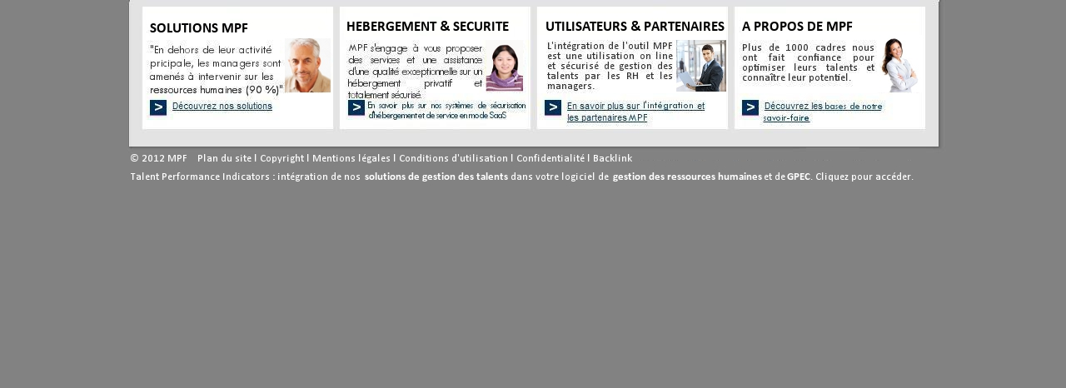

1

3

15

14

13

12

11

10

8

4

9

7

6

5

2

|  |  |  |  |  |  |
| --- | --- | --- | --- | --- | --- |
| Number | Title | Type | Displays Rules | Interactions rules | Comment |
| 1 | Title | Text zone | Permanente |  | * Pictures, texts, … must be editable in the back office (BO). * Texts are default justified * The presentation of the sections: « Hébergement & Sécurité » « Utilisateurs & Partenaires » and « A Propos de MPF » and their interactions are the same as the section « Solutions MPF ». * Those elements and interactions are similar on all pages. |
| 2 | Text |  |
| 3 | Picture | Picture |  |
| 4 | anchor text | button + anchor text | By clicking: go to the « les 12 applications » page (sub-section of the « solutions MPF » section. |
| 5 | « Hébergement & Sécurité » section |  |  |
| 6 | « Utilisateurs & Partenaires » section |  |  |
| 7 | « A Propos de MPF » section |  |  |
| 8 | © 2012 MPF | Text zone |  | Editable content in the BO |
| 9 | Website map | By clicking: go to the « Plan du site » page | * Texts, links must be editable in the BO. * Plan the possibility of deleting or creating new sections (10 slots) * Those elements and interactions are similar on all pages. |
| 10 | Copyright | By clicking: go to the « Copyright» page |
| 11 | Legal | By clicking: go to the « Mentions légales» page |
| 12 | Terms of use | By clicking: go to the « Conditions d’utilisations» page |
| 13 | Confidentiality | By clicking: go to the « Confidentialité» page |
| 14 | Backlink | By clicking: go to the « Backlink» page |
| 15 | « Talent Performance Indicators … » sentence | By clicking: go to the « Contact» page | Editable content, Plan the possibility to bold and manage the layout of the text. |

### Home page “Accueil”

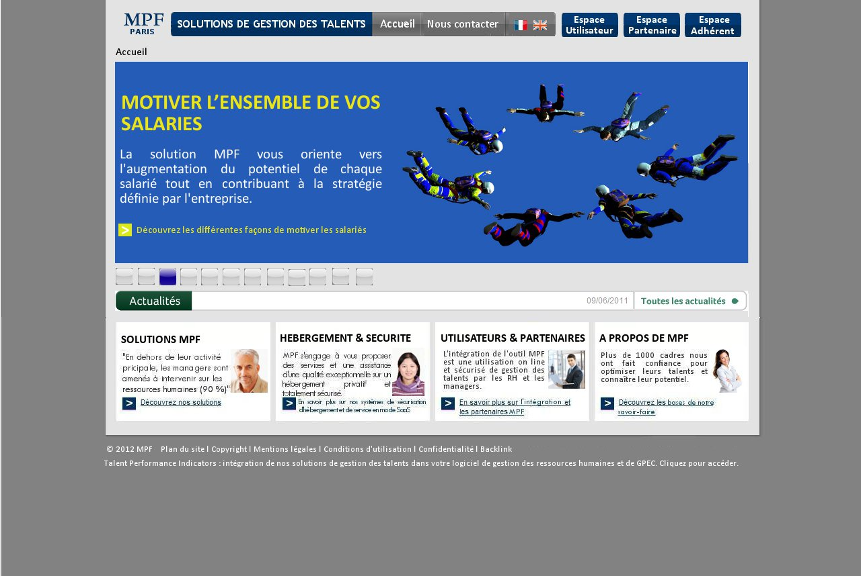

11

10

9

7

8

2

1

4

5

6

3

|  |  |  |  |  |  |
| --- | --- | --- | --- | --- | --- |
| Number | Title | Type | Displays Rules | Interactions rules | Comment |
| 1 | Header |  |  |  | See « Header » section |
| 2 | Breadcrumb | Text | Permanent |  |  |
| 3 | Picture | Picture | 12 scrolling pictures. The title, the text … also change each time. | By clicking on each anchor text, go to the « fiche de produit » corresponding page (cf. website model) | * Pictures, texts, … must be editable in the back office (BO). * Plan the possibility of choosing the color, the font and the size of the text and the anchor text. * Plan the possibility of managing the text layout. |
| 4 | Title en h1 | Texte riche |
| 5 | Text |
| 6 | anchor texte | Button + anchor text |
| 7 | Button | Buttons | Each button represents the 12 pictures above. By default buttons are in grey, only the one displayed is in blue | By clicking on each button, display the corresponding picture. | * The designer can suggest prettier buttons in line with the website colors. |
| 8 | “Actualités” | Text zone | Permanent |  | * Editable content in the back office (BO). * Plan the possibility to ad 30 actualities in the « actualité générale » page. |
| 9 | Actuality title | Text zone | Scrolling titles | By clicking on a title, lead to the “actualité” page corresponding. |
| 10 | “Toutes les actualités” | Text zone | Permanent | By clicking: lead to the « actualité générale » page, which contain a list of all actualities. |
| 11 | Footer |  |  |  | See the « footer » section |

### The product sheet

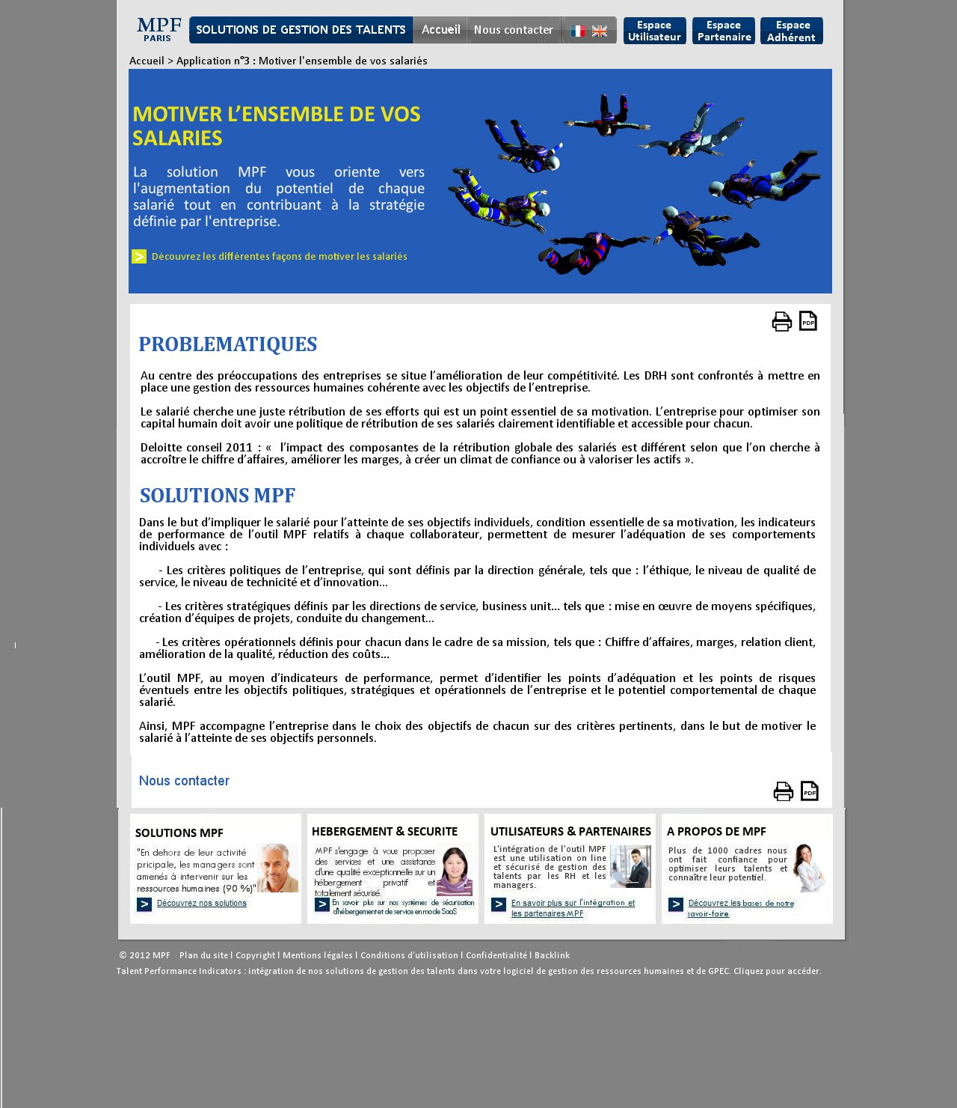

9

8

7

6

4

4

2

1

7

6

5

5

3

|  |  |  |  |  |  |
| --- | --- | --- | --- | --- | --- |
| Number | Title | Type | Displays Rules | Interactions rules | Comment |
| 1 | Header |  |  |  | See the « Header » section |
| 2 | Breadcrumb | Text | Permanent | By clicking on « accueil », lead to the home page. | The last level of the “Breadcrumb” (in this screen print it is “Application n°3) is not clickable. |
| 3 | Same elements as the home page |  |  |  | See home page, but each product sheet has only one picture (no animation). |
| 4 | Title en h2 | Active zone | Permanent |  | * Editable content in the back office (BO). * Default justified texts.. * Plan the possibility of choosing the color, the font and the size of the text (possibility to put in bold). * Plan the possibility of managing the text layout. * Plan the possibility of deleting or ad pictures. |
| 5 | Texts | Permanent |  |
| 6 | Print icon | Permanent | By clicking: print page |
| 7 | PDF icon | Permanent | By clicking: download in PDF |
| 8 | “Nous contacter” | Permanent | By clicking: lead to the “contact” page. |
| 9 | Footer |  |  |  | See the « footer » section |

Remark: the presentation of the 11 others products sheets is identical (cf. product sheet model)

### “Solutions MPF” section

* + 1. « un outil de gestion des talents » sub-section

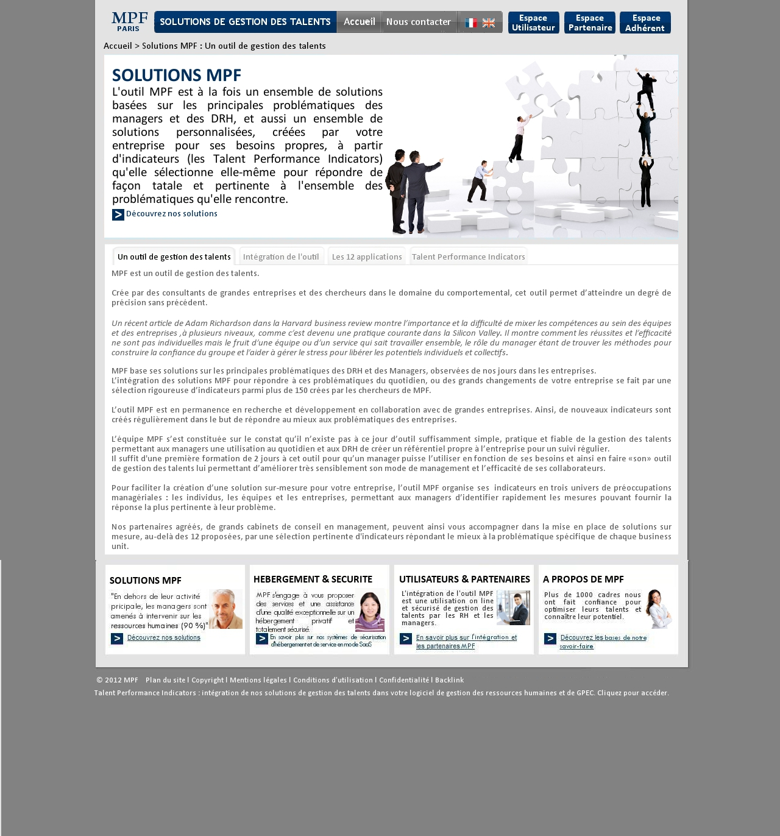

9

2

1

6

8

7

7

7

7

5

4

3

* + 1. Full content after clicking on « découvrez nos solutions »

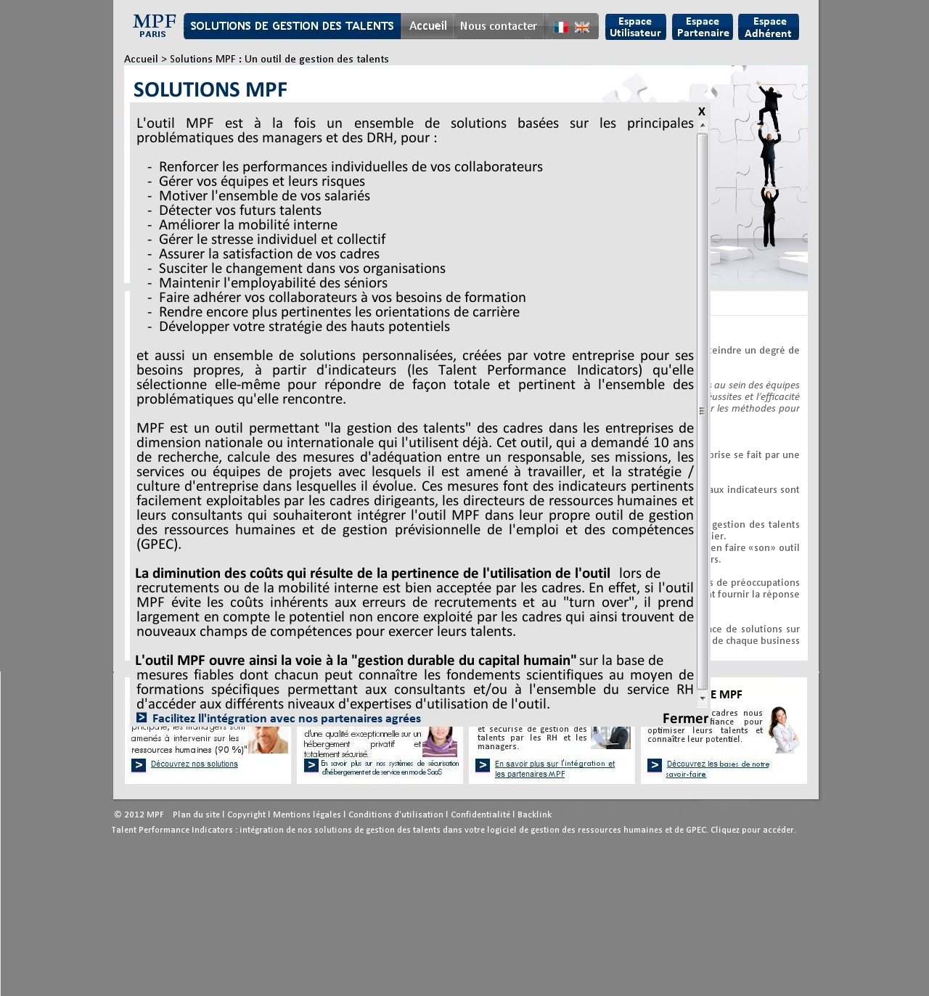

10

10

11

|  |  |  |  |  |  |
| --- | --- | --- | --- | --- | --- |
| Number | Title | Type | Displays Rules | Interactions rules | Comment |
| 1 | Header |  |  |  | See the « Header » section |
| 2 | Breadcrumb | Text | Permanent | By clicking on « accueil », lead to the home page. | The last level of the Breadcrumb isn’t clickable. |
| 3 | Picture | Picture | Permanent |  | Plan the possibility to edit pictures. |
| 4 | Title en h1 | Zone riche | Permanent |  | * Editable content in the BO. * For the zone riche, texts are justified by default. * Plan the possibility of deleting or adding of the h2 title, of the text, of the picture, of hyperlinks…. * Plan the possibility of choosing the color, the font and the size of the text (possibility of bold). * Plan the possibility of managing the text layout. |
| 5 | Text |  |
| 6 | Anchor text | Button + text zone | By clicking: display le full text (grey background) over the page. |
| 7 | Title of sub section | Text zone | Permanent, in grey by default, when the content of a sub section is displayed the title must be in black. | By clicking on each sub section, display the corresponding content (cf. website model). |
| 8 | Sub section content | Zone riche | Permanent, texts are in grey. The size of this zone must be automatically adjusted to the size of the content. |  |
| 9 | Footer |  |  |  | See the « footer » section |
| 10 | Close “fermer” and  « X » | Buttons | Hide by default, display when clicking on « découvrez nos solutions » | By clicking on « fermer » ou « X », display the short text |  |
| 11 | Anchor text | Button + text zone | By clicking: lead to the « partenaires » page |  |

* + 1. « Intégration de l’outil » sub-section

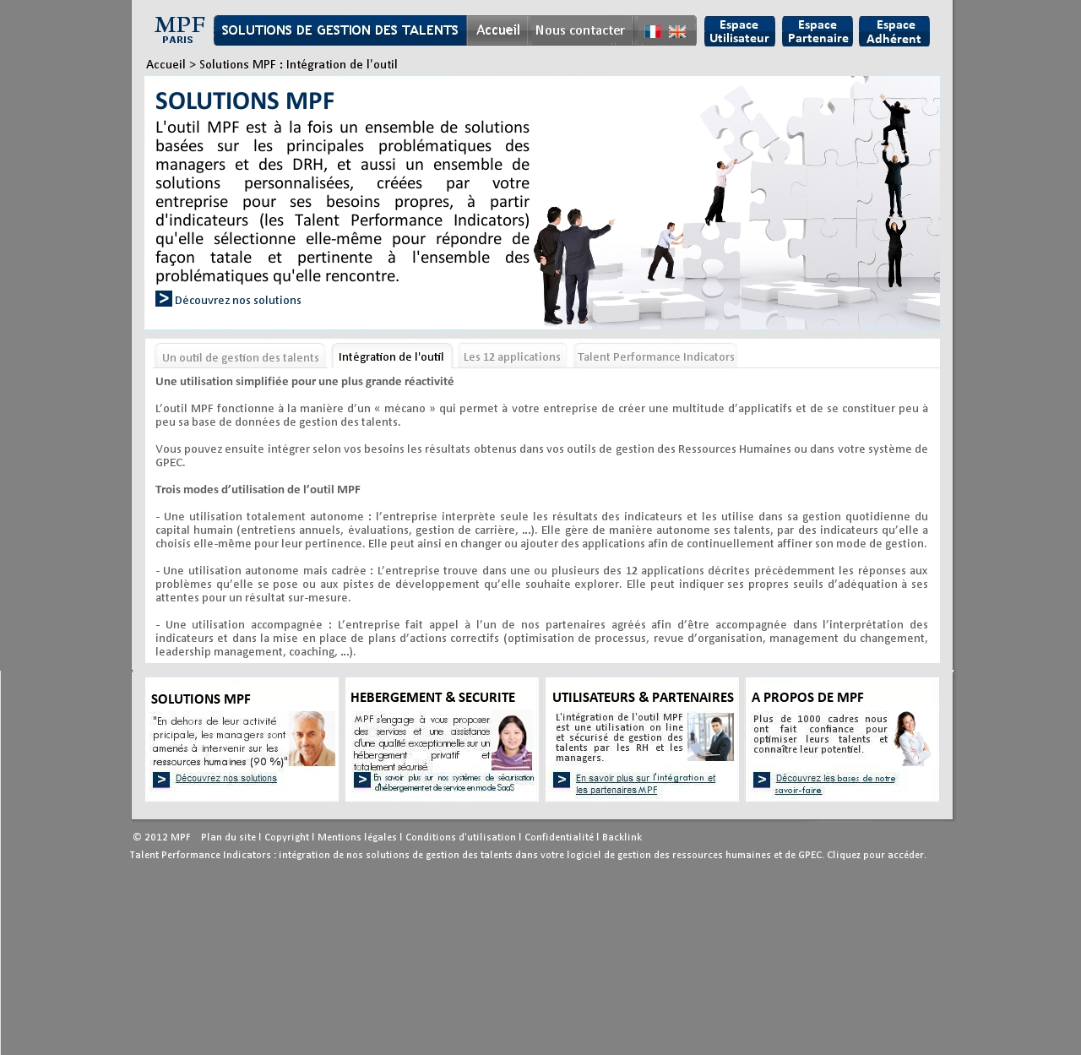

Remark: identical to the « un outil de gestion des talents » sub-section

* + 1. « les 12 applications » sub-section

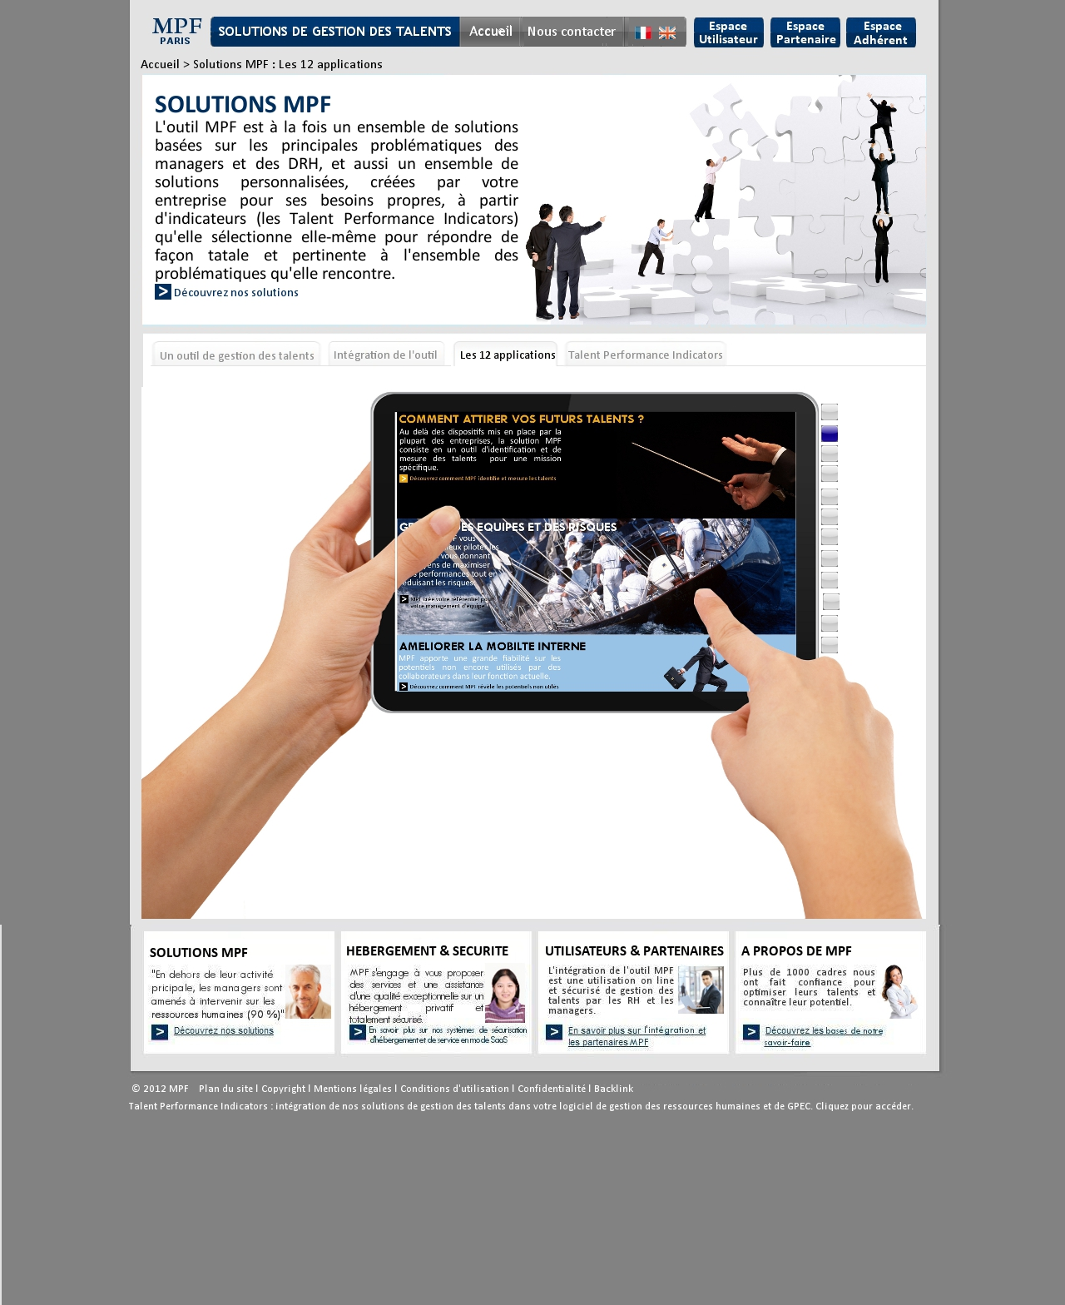

1

2

Remark: identical to the « un outil de gestion des talents » sub-section but the point under:

|  |  |  |  |  |  |
| --- | --- | --- | --- | --- | --- |
| Number | Title | Type | Displays Rules | Interactions rules | Comment |
| 1 | Content zone of the sub-section | Picture + animation | 12 scrolling pictures, 3 pictures can be seen at the same time on the screen. The screen is like an “Ipad”. | Only the middle image can be clickable. When click: leads to the corresponding « fiche de produit » page. |  |
| 2 | Boutons voyants | Buttons | Each button stands for one of the 12 pictures. By default in grey the button become bleu when the picture is clickable. | By clicking on grey button, display the corresponding picture, and the two none clickable (the previous and the next). | * The designer can suggest prettier buttons in line with the website colors. |

* + 1. « Talent Performance Indicators » sub-section

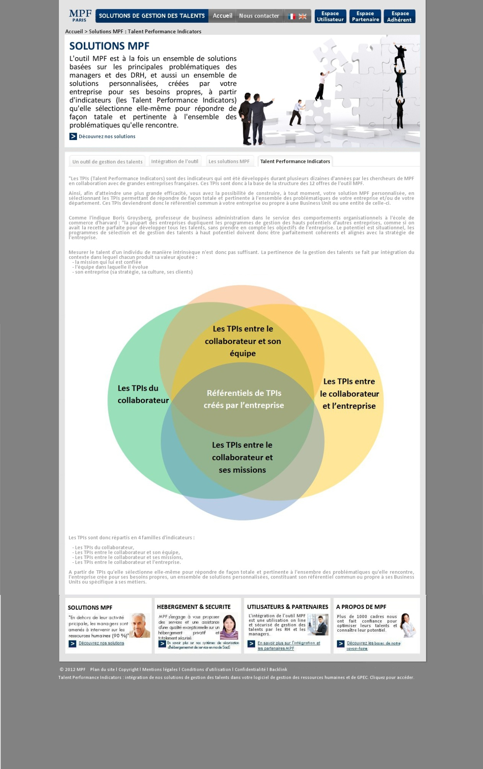

Remark: identical to the « un outil de gestion des talents » sub-section

### « Hébergement & Sécurité » section

* + 1. « Hébergement » sub-section

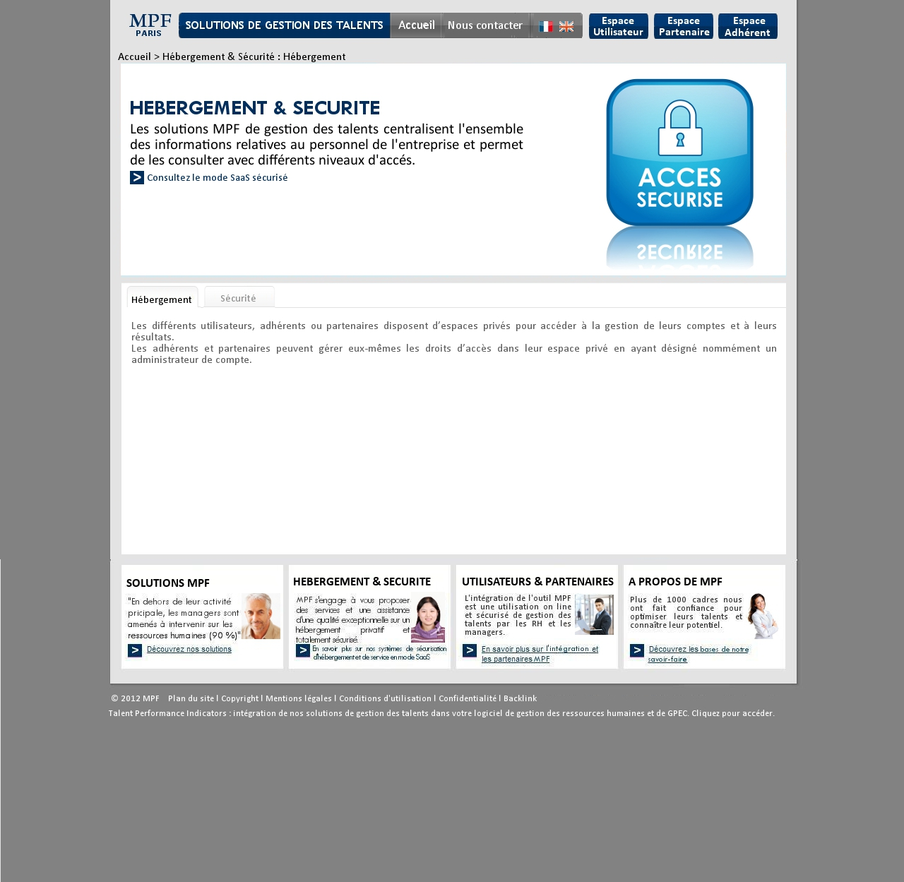

Remark: identical to the « un outil de gestion des talents » sub-section

* + 1. « Sécurité » sub-section

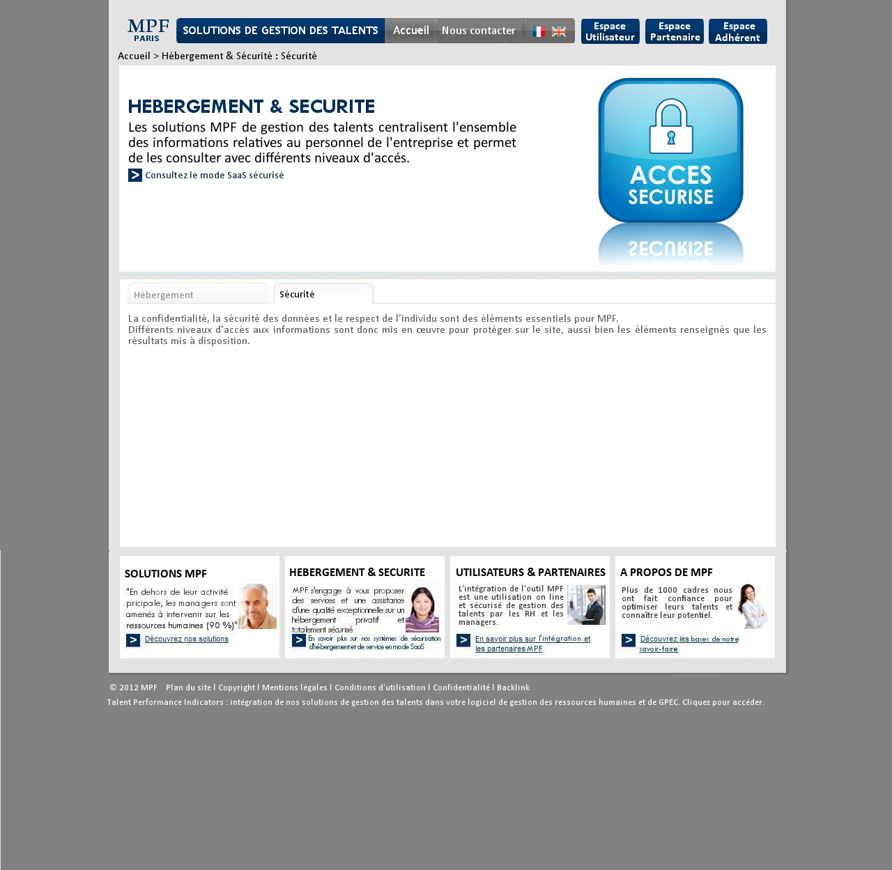

Remark: identical to the « un outil de gestion des talents » sub-section

### « Utilisateurs & Partenaires » section

* + 1. « Utilisateurs » sub-section

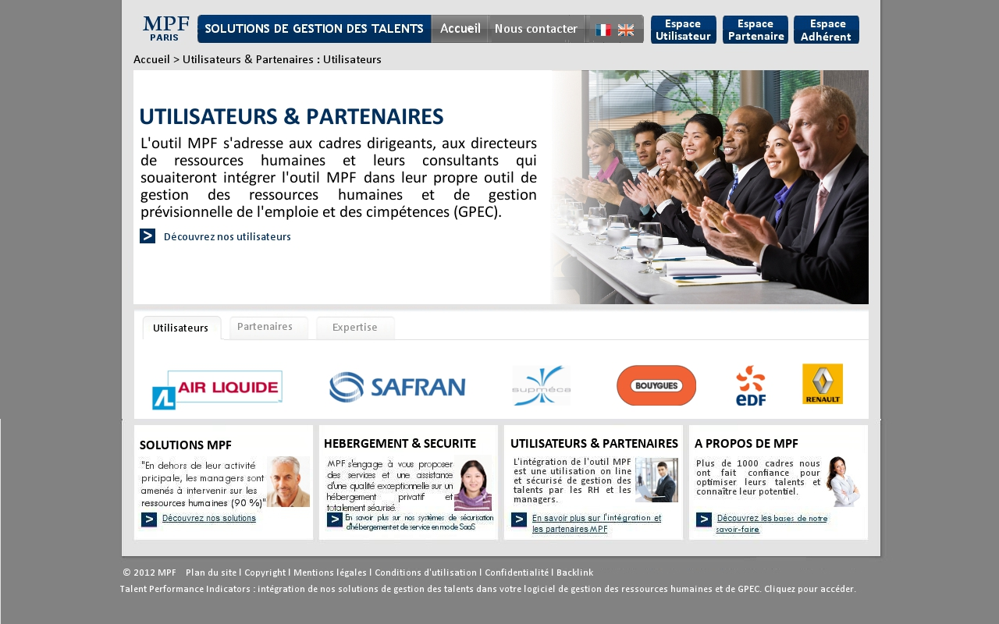

9

8

2

1

7

7

7

6

5

4

3

* + 1. Full content when clicking on « découvrez nos utilisateurs »

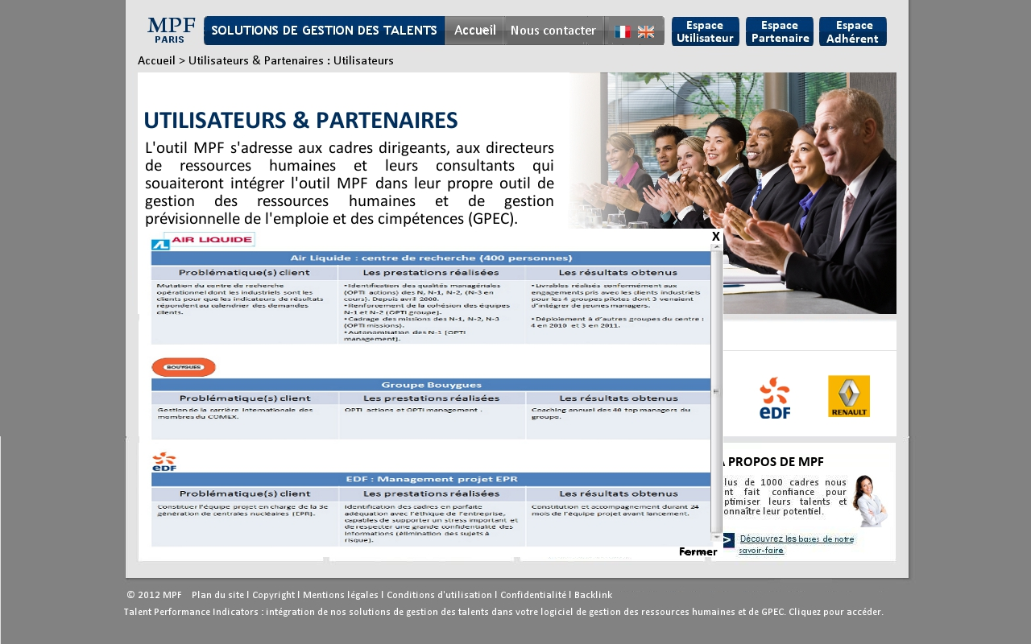

12

12

11

11

11

10

10

10

* + 1. User testimony sheet

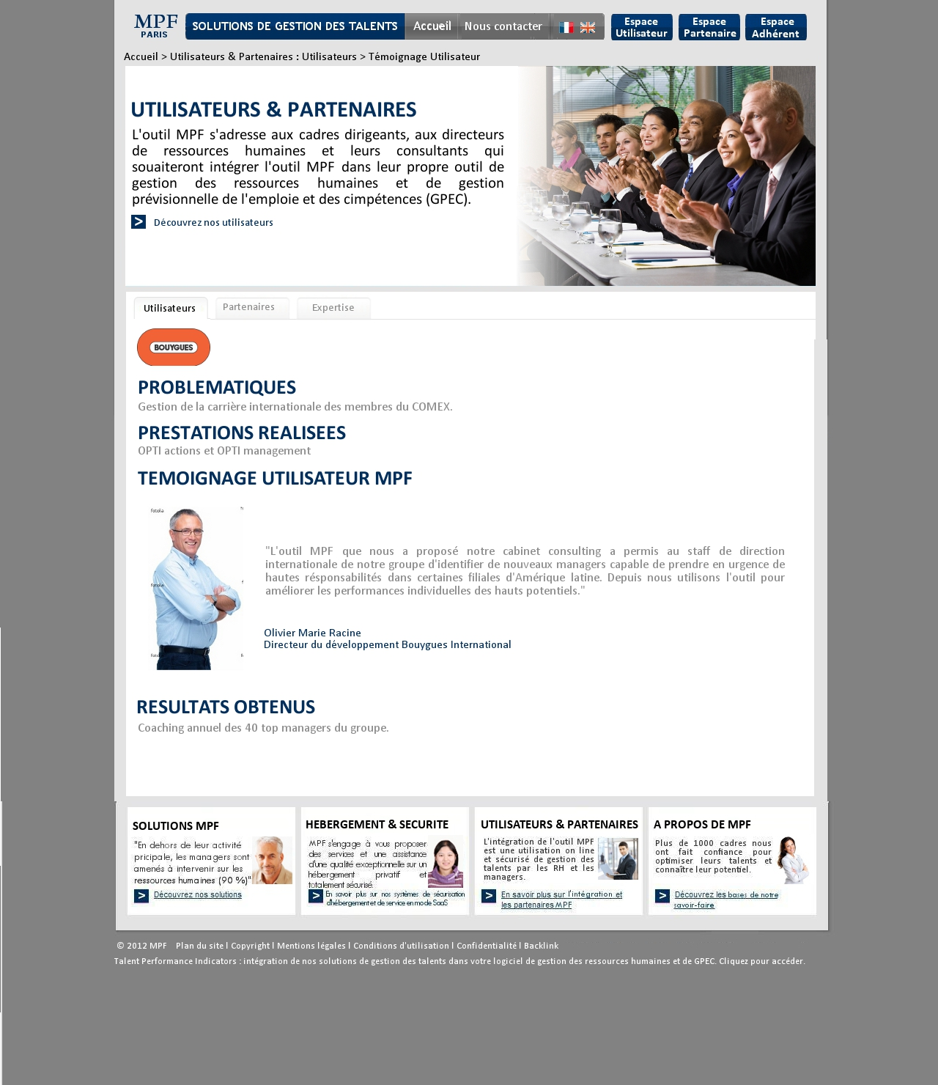

13

|  |  |  |  |  |  |
| --- | --- | --- | --- | --- | --- |
| Number | Title | Type | Displays Rules | Interactions rules | Comment |
| 1 | Header |  |  |  | See the « Header » section |
| 2 | Breadcrumb | Text | Permanent | By clicking on « accueil », lead to the home page. | The last level of the Breadcrumb isn’t clickable. |
| 3 | Picture | Picture | Permanent |  | Plan the possibility to edit pictures. |
| 4 | Title en h1 | Zone riche | Permanent |  | * Editable content in the BO. * For the zone riche, texts are justified by default. * Plan the possibility of deleting or adding of the h2 title, of the text, of the picture, of hyperlinks…. * Plan the possibility of choosing the color, the font and the size of the text (possibility of bold). * Plan the possibility of managing the text layout. |
| 5 | Text |  |
| 6 | Anchor text | Button + text zone | By clicking: display le full text (grey background) over the page. |
| 7 | Title of sub section | Text zones | Permanent, in grey by default, when the content of a sub section is displayed the title must be in black. | By clicking on each sub section, display the corresponding content (cf. website model). |
| 8 | Content of the sub-section | zone riche | Permanent, texts are in grey. The size of this zone must be automatically adjusted to the size of the content. | By clicking on each logo, only the zone that has users logos is refreshed and the user testimony sheet is displayed. |
| 9 | Footer |  |  |  | See the « footer » section |
| 10 | Logo | Picture | Hide by default, display when clicking on « découvrez nos solutions » | By clicking: lead to the corresponding user testimony sheet | * Editable content in the BO. * Plan the possibility of managing the pictures * Texts are justified by default. * Plan the possibility of deleting or adding of the h2 title, of the text, of the picture, of hyperlinks…. * Plan the possibility of choosing the color, the font and the size of the text (possibility of bold). * Plan the possibility of managing the text layout. |
| 11 | Text | Table |
| 12 | Close (“fermer”) and  « X » | Buttons | By clicking on « fermer » or « X », display the short text |
| 13 | User testimony sheet | Zone riche | Displayed after clicking on a “logo” in the “utilisateurs” section.  The zone size must be automatically adjust to the content size. |  |

2.7.4 « Partenaires » sub-section

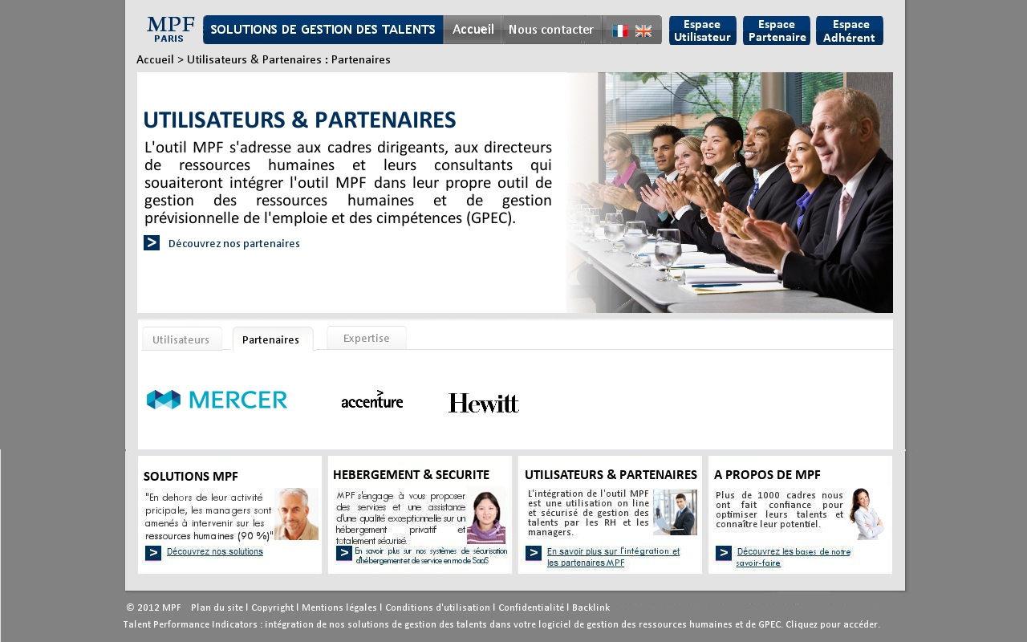

2.7.5 Full content after clicking on « découvrez nos partenaires »

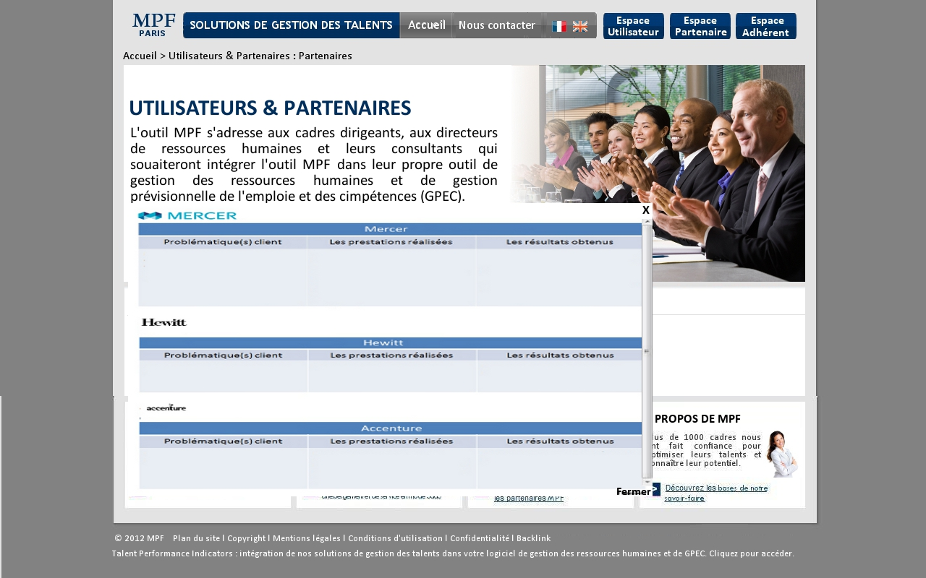

* + 1. Partners testimony sheet

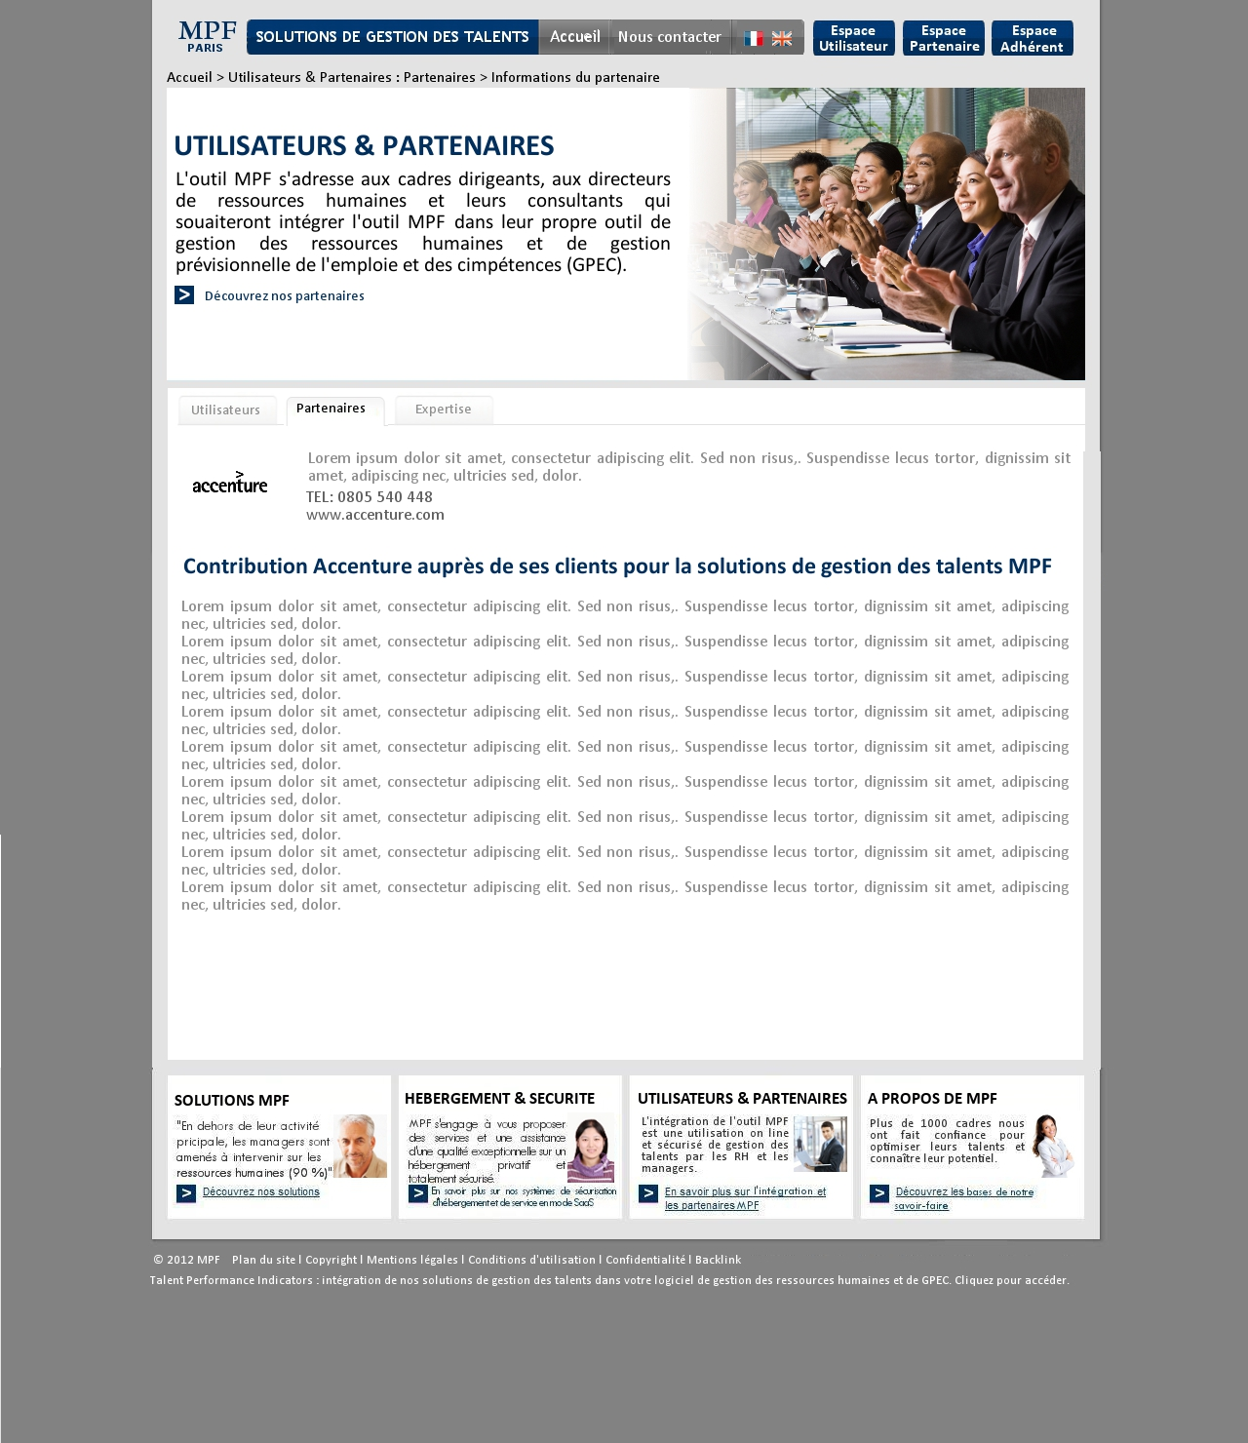

* + 1. « Expertise » sub-section

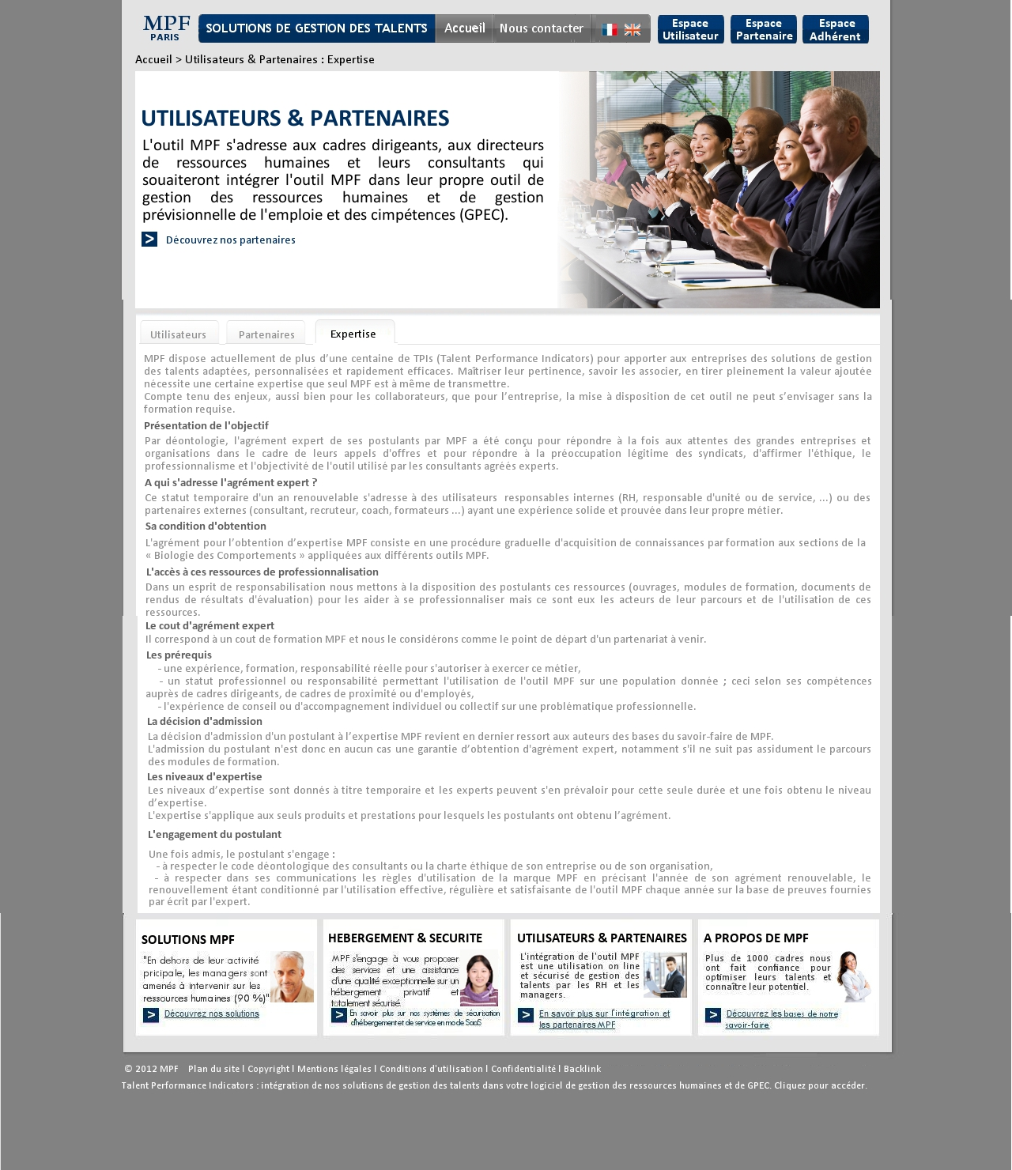

Remark: identical to the « un outil de gestion des talents » sub-section

### « A Propos de MPF » section

* + 1. « Historique » sub-section

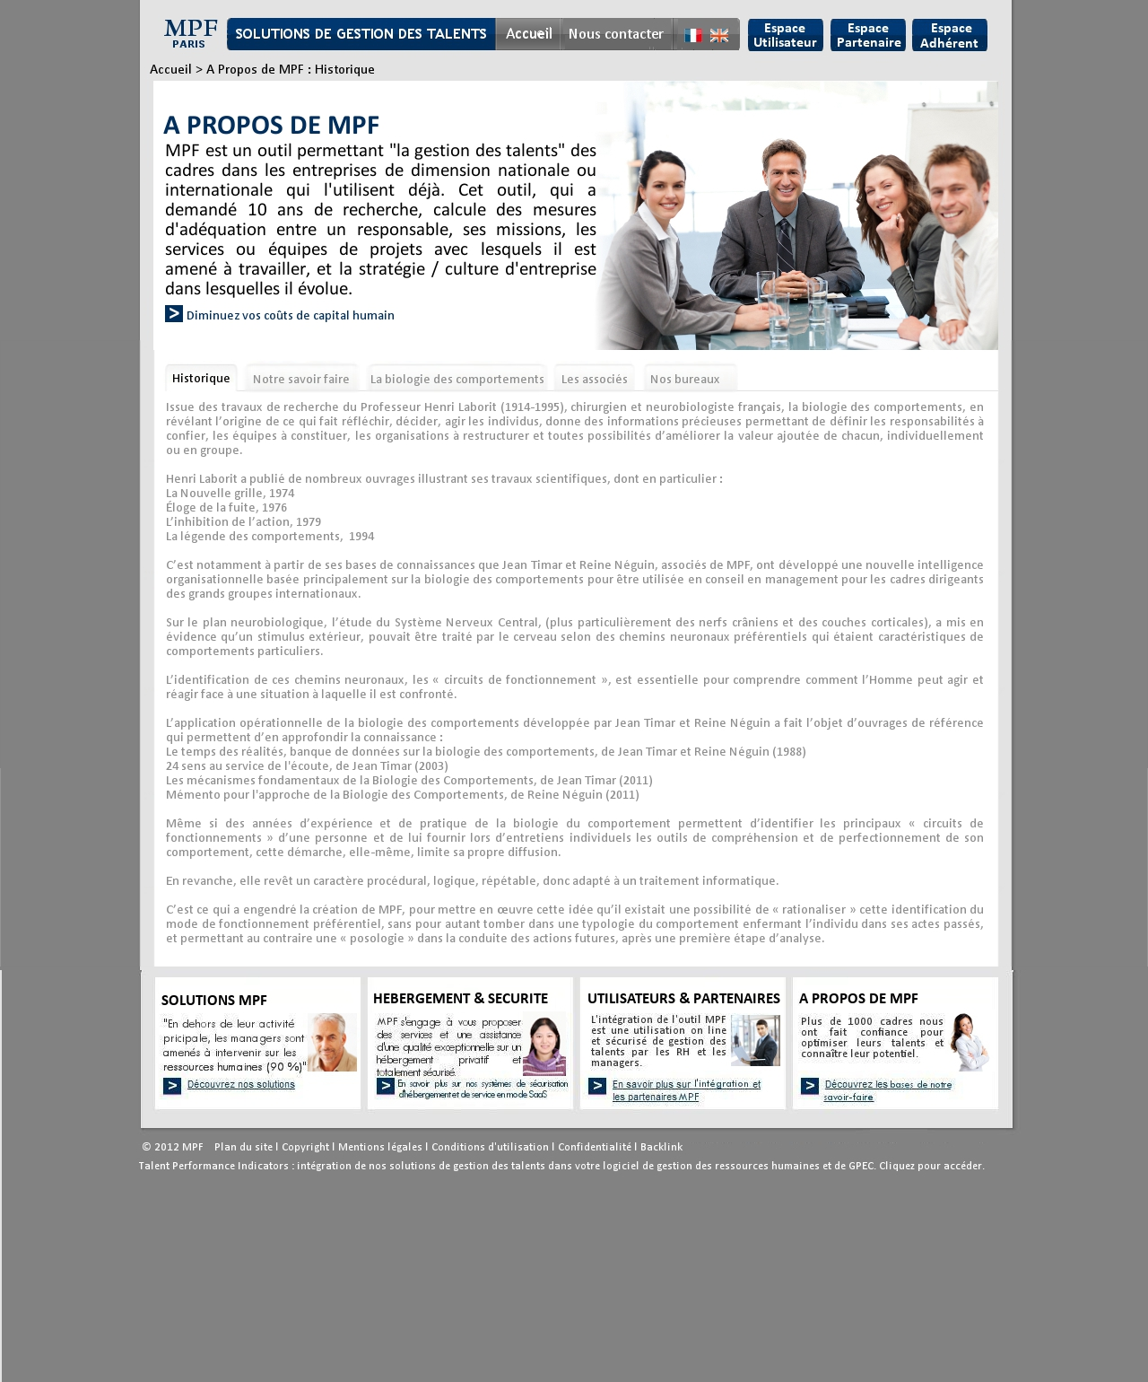

Remark: identical to the « un outil de gestion des talents » sub-section

* + 1. Full content after clicking on « diminuez vos coûts de capital humain »

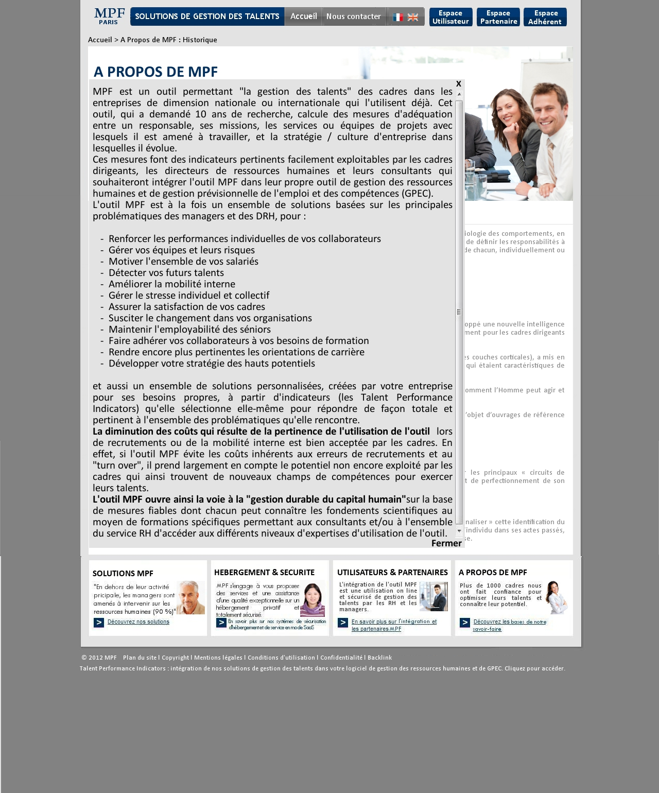

Remark: identical to the « un outil de gestion des talents » sub-section

* + 1. « Notre savoir-faire » sub-section

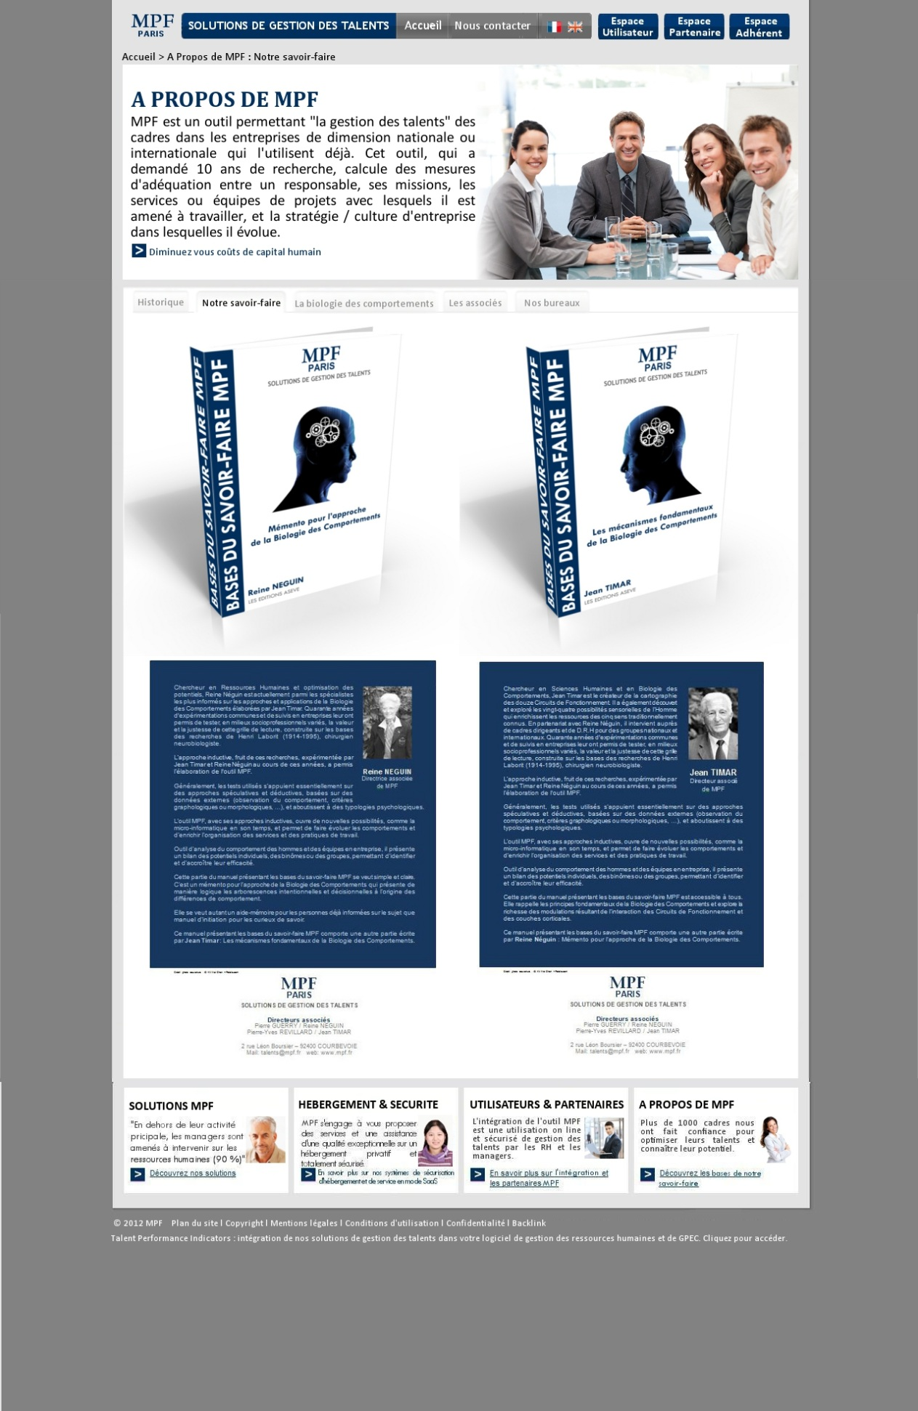

Remark: identical to the « un outil de gestion des talents » sub-section, but the content presentation of this sub-section (yellow zone), had 4 pictures

* + 1. « La biologie des comportements » sub section

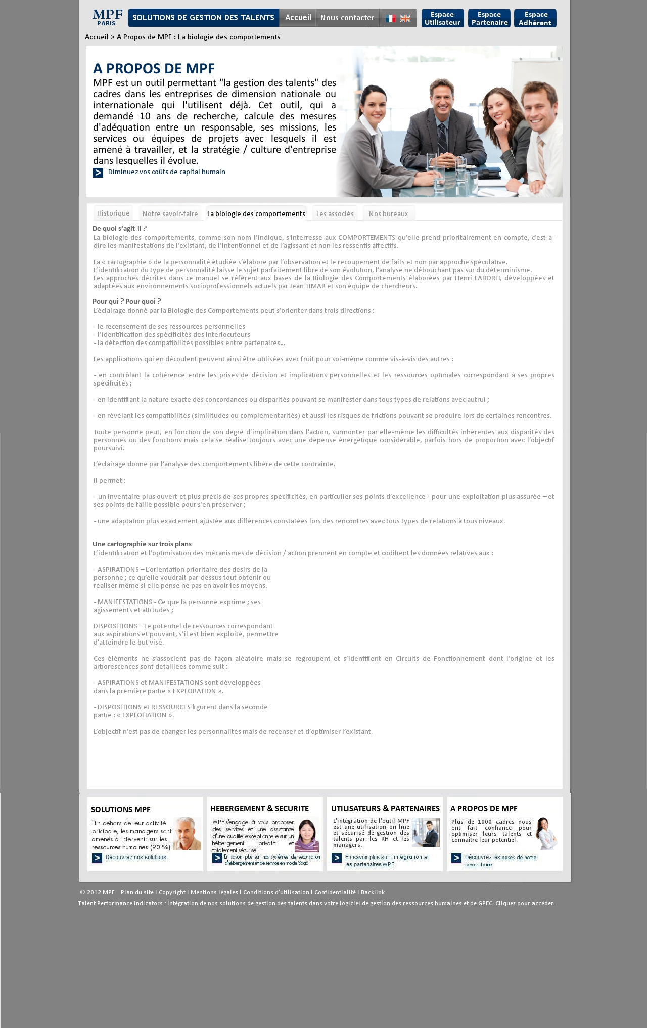

Remark: identical to the « un outil de gestion des talents » sub-section

* + 1. « Les associés » sub-section

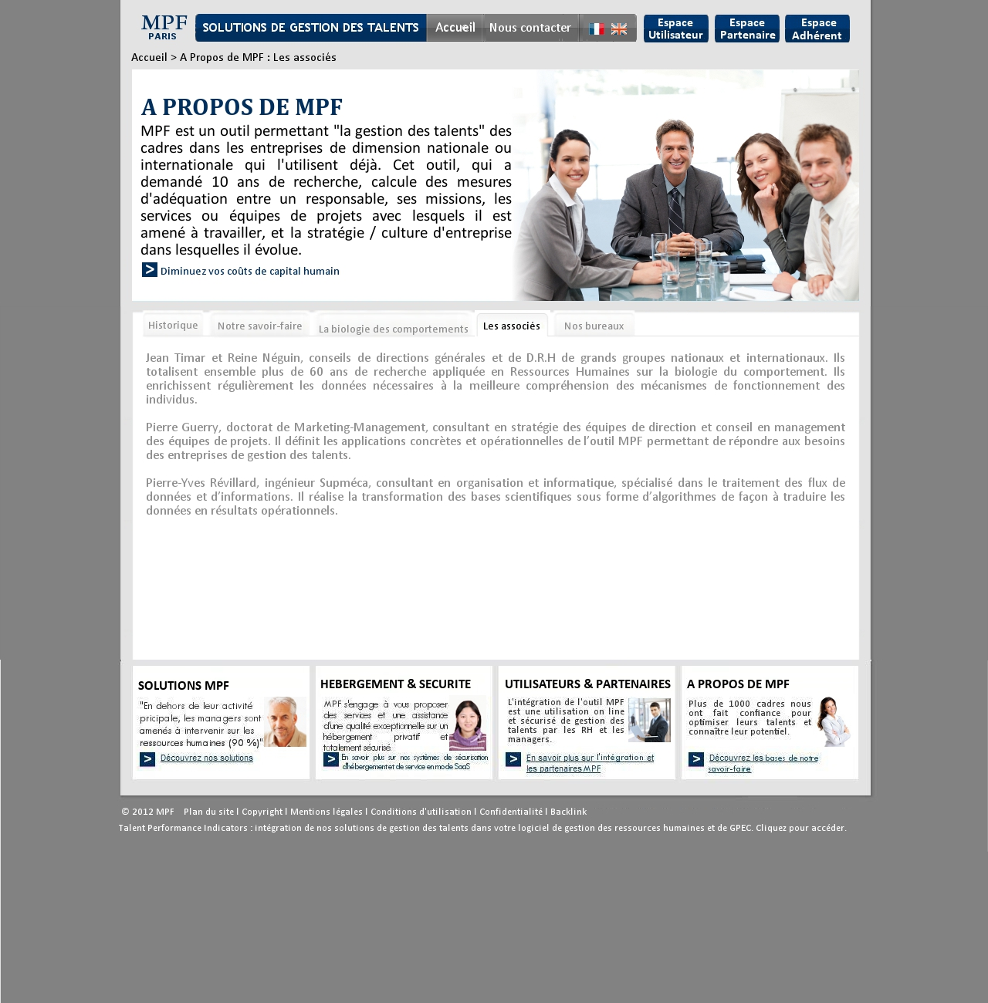

Remark: identical to the « un outil de gestion des talents » sub-section

* + 1. « Nos bureaux » sub-section

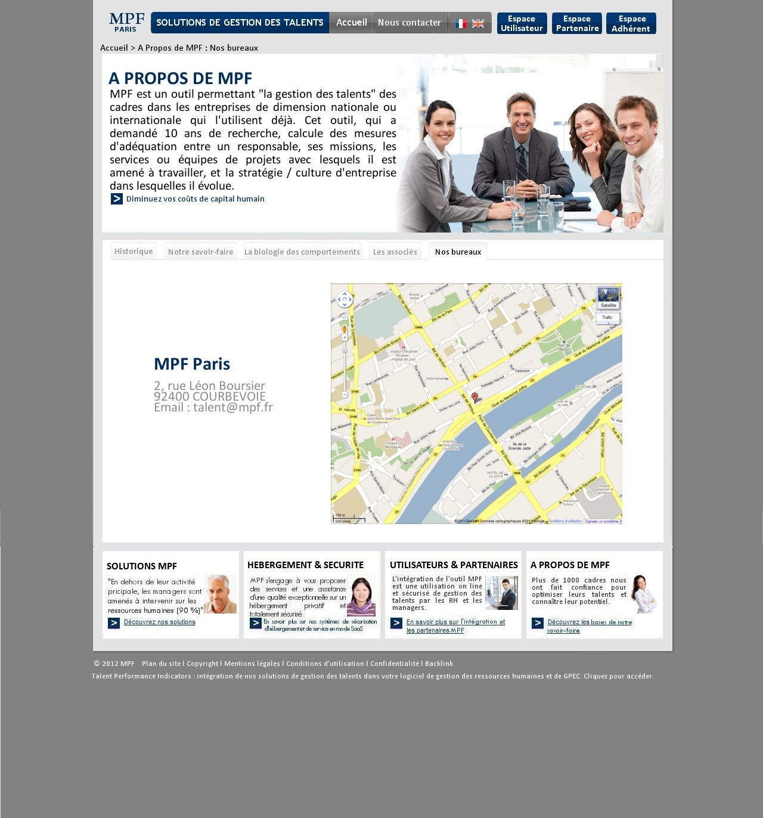

2

1

Remark: identical to the « un outil de gestion des talents » sub-section but the point under:

|  |  |  |  |  |  |
| --- | --- | --- | --- | --- | --- |
| Number | Title | Type | Displays Rules | Interactions rules | Comment |
| 1 | Company information | Text zone | Permanent | By clicking on the email address, open the mailbox and put this email in the “to” field | Editable content in the BO. |
| 2 | Google map | Map | Permanent. Place the company on the map. | Same function as Google map when clicking on the red flag. |  |

### Other pages

* + 1. « Plan du site » Page

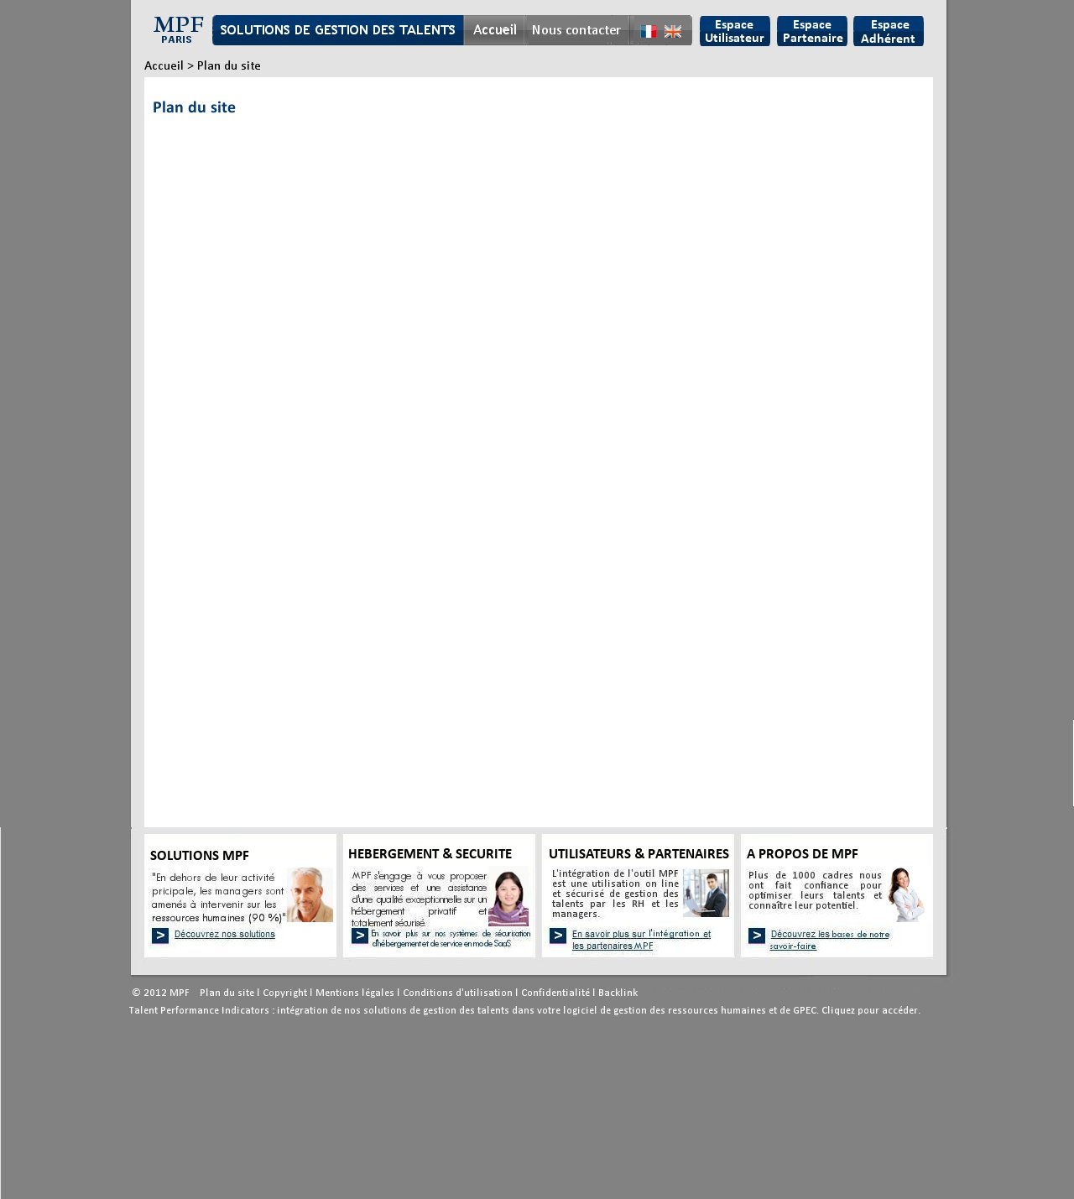

Remark: identical to the « Copyright » page, but the content has an hyperlink list, when clicking on each list, that leads to the corresponding website section.

* + 1. « Copyright » page

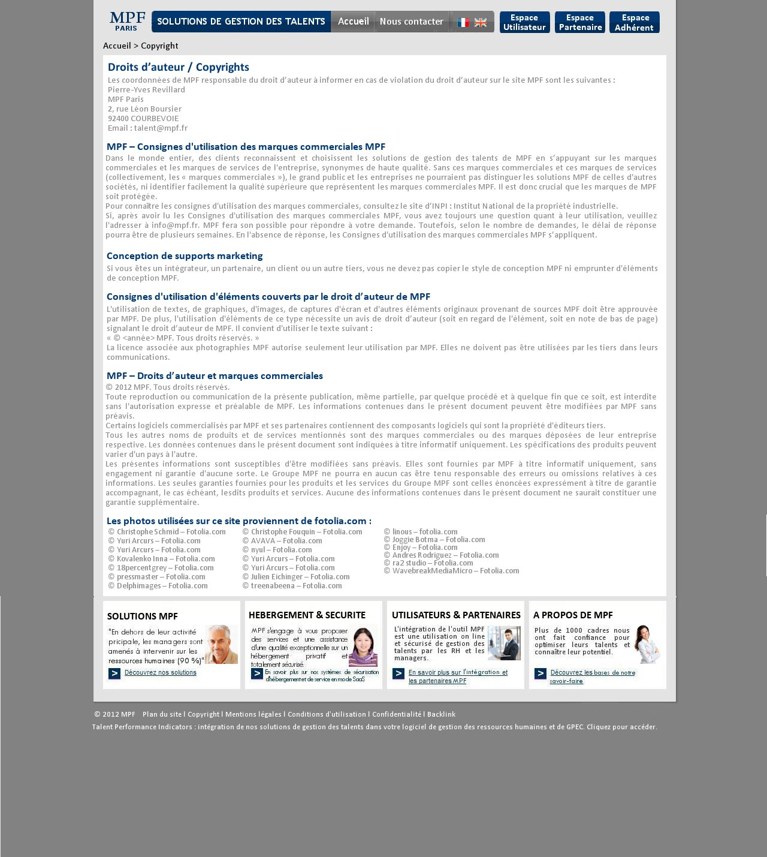

4

5

5

4

4

5

4

5

2

1

6

5

4

3

7

|  |  |  |  |  |  |
| --- | --- | --- | --- | --- | --- |
| Number | Title | Type | Displays Rules | Interactions rules | Comment |
| 1 | Header |  |  |  | See the « header » section |
| 2 | Breadcrumb | Text | Permanent | By clicking on « accueil », lead to the home page. | The last level of the Breadcrumb isn’t clickable. |
| 3 | Title en h1 | Text zone | Permanente |  | * Editable content in the BO. * Plan the possibility of choosing the color, the font and the size of the text (possibility of bold). |
| 4 | Title en h2 | Zone riche | Display the content wrote in the BO, the size of the zone must be automatically adjust to the text size. |  | * Editable content in the BO. * Texts are justified by default. * Plan the possibility of deleting or adding of the h2 title, of the text, of the picture, of hyperlinks…. * Plan the possibility of choosing the color, the font and the size of the text (possibility of bold). |
| 5 | Text |
| 6 | Pictures list of fotolia.com | By clicking on each list, leads to the corresponding page of fotolia.com | Editable content and links.  Plan the possibility to ad as much as needed. |
| 7 | Footer |  |  |  | See the « footer » section |

* + 1. « Confidentialité » page

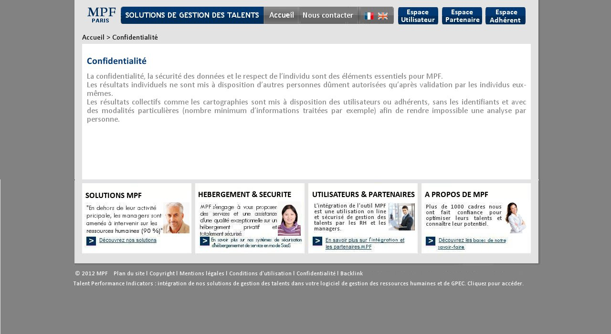

Remark: identical to the « Copyright » page.

* + 1. « Conditions d’utilisation » page

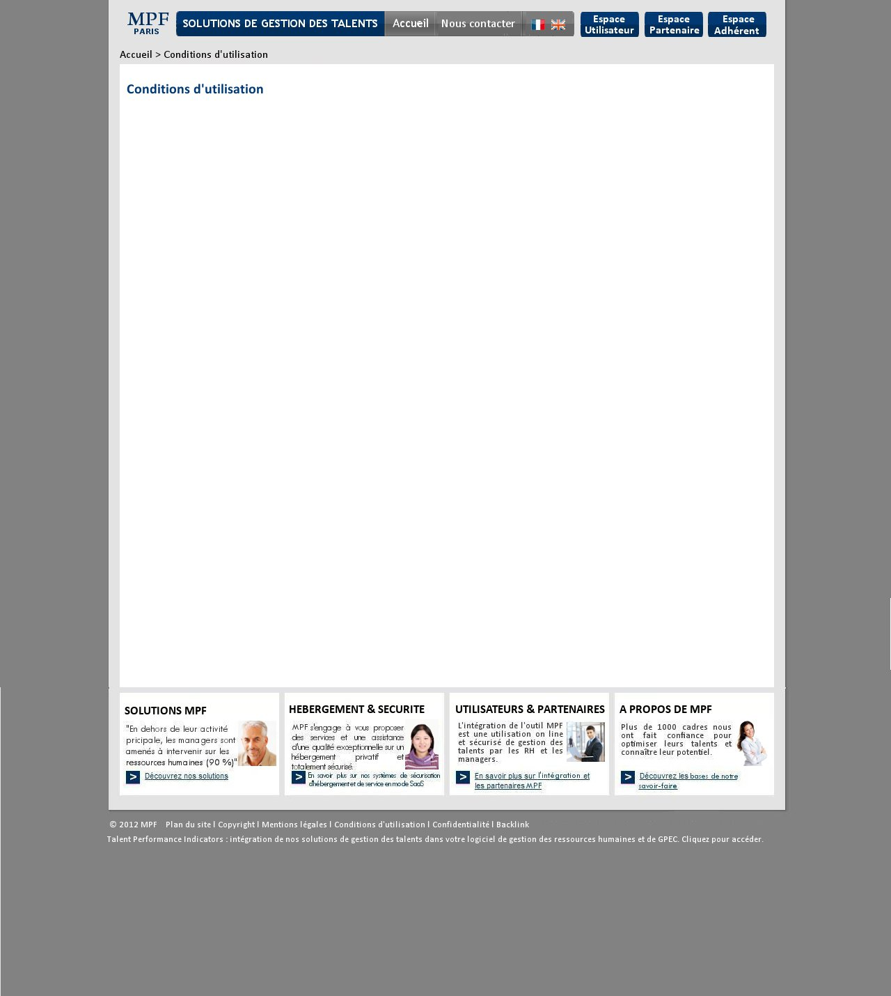

Remark: identical to the « Copyright » page.

* + 1. « Mentions légales » page

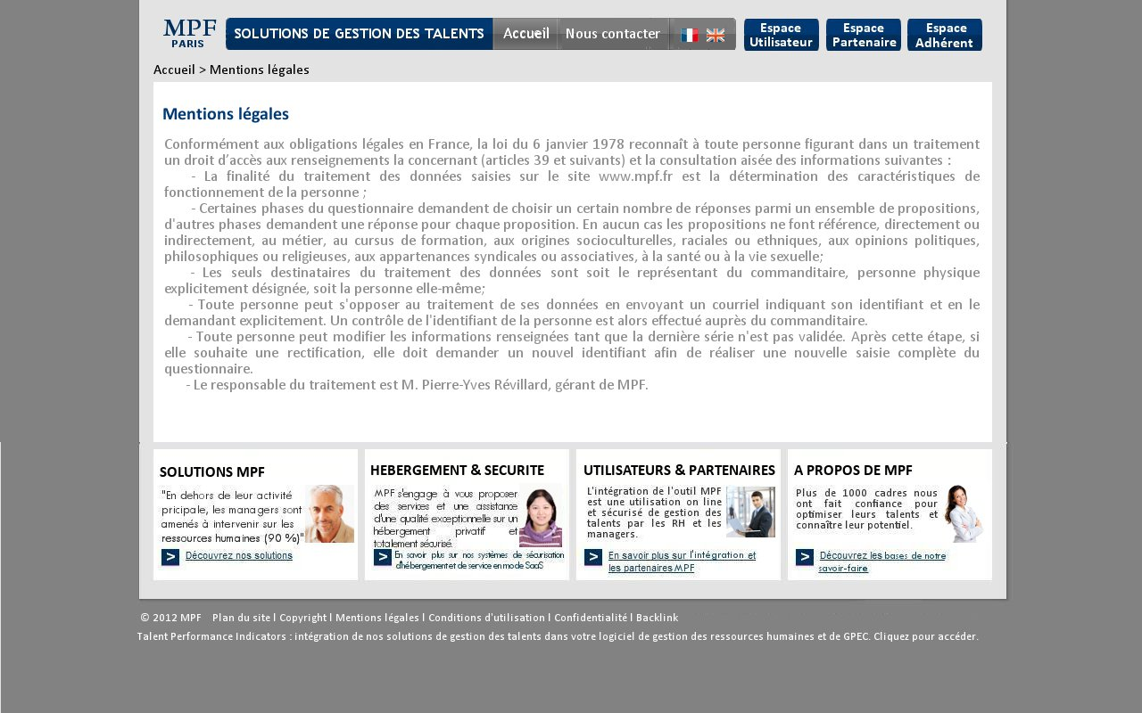

Remark: identical to the « Copyright » page.

* + 1. « Backlink » page

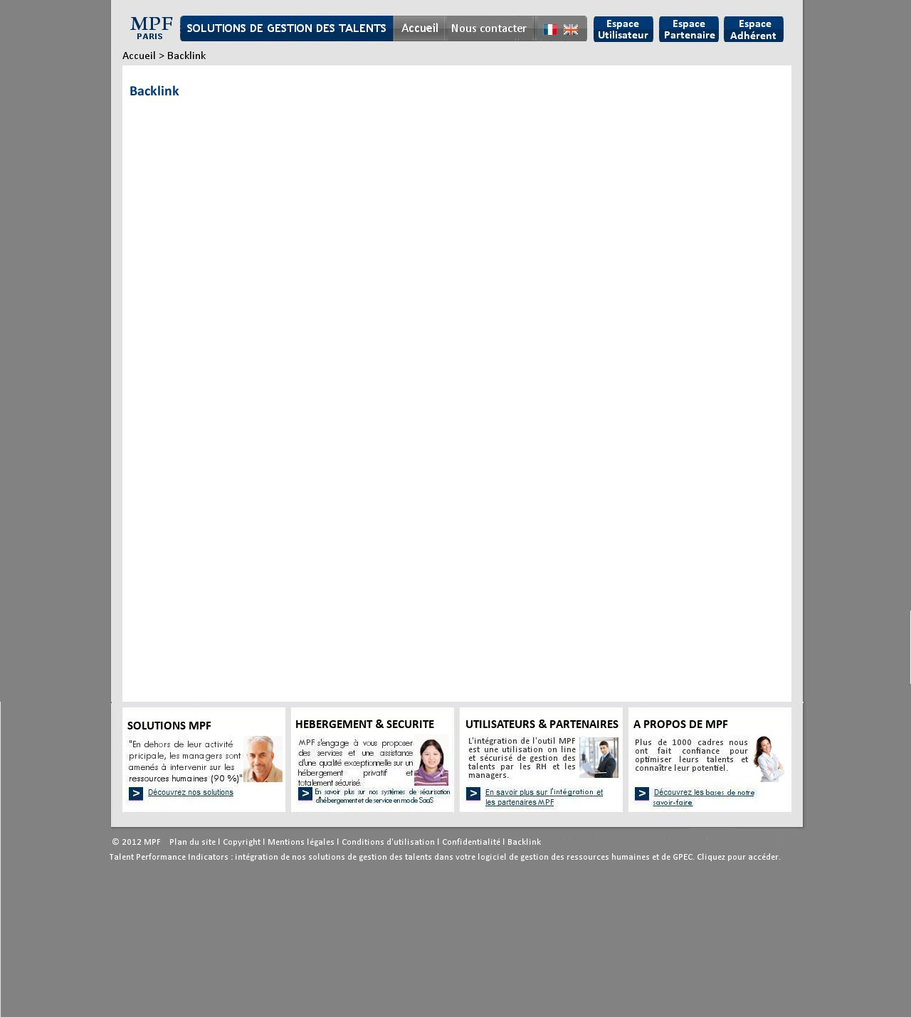

Remark: identical to the « Copyright » page.

* + 1. « Contact » page

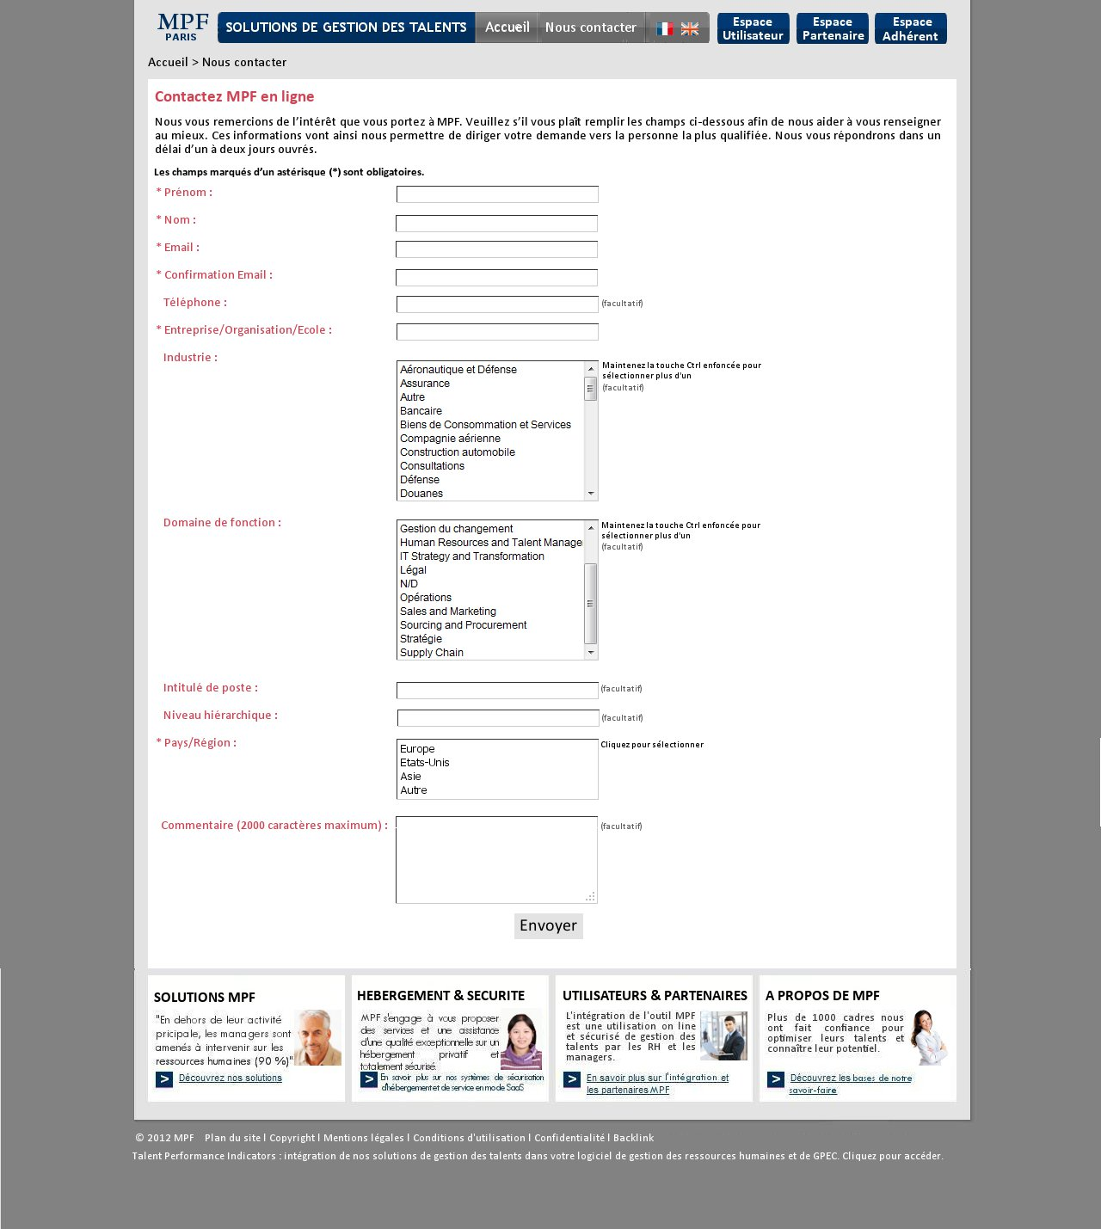

7

8

7

8

7

5

9

10

5

6

2

1

5

5

4

3

|  |  |  |  |  |  |
| --- | --- | --- | --- | --- | --- |
| Number | Title | Type | Displays Rules | Interactions rules | Comment |
| 1 | Header |  |  |  | See the « Header » section |
| 2 | Breadcrumb | Text | Permanent | By clicking on « accueil », lead to the home page. | The last level of the Breadcrumb isn’t clickable. |
| 2 | Title en h1 | Text zone | Permanent |  | Editable content |
| 3 | Text |
| 4 | Instruction text |
| 5 | Name of each form field |
| 6 | Form field | Free field | Free default |  | The size of the zone must be automatically adjusted to the content size. |
| 7 | Form field with lift | List | Permanent |  | Editable content, possibility of adding and deleting. |
| 8 | “envoyer” (send) button | Button | Permanent | By clicking (if all field required are filled):   * Send the form to talent@mpf.fr. * Send the commercial leaflet to the email address filled in the form. * Display the following message in a pop-up: “Merci, notre plaquette commerciale vient de vous être adressé par email.” | If on or more field required are not filled, when clicking on the “envoyer” button, display the following error message in a pop-up : “merci de remplir tous les champs obligatoires avant d’envoyer le formulaire” |
| 9 | Footer |  |  |  | See the « footer » section |

Remark: ad a control between the to fields: « email » and « confirmation email »

### Account spaces (utilisateurs / partenaires / adhérents)

* + 1. Pop-up displayed after clicking on “espace utilisateur”

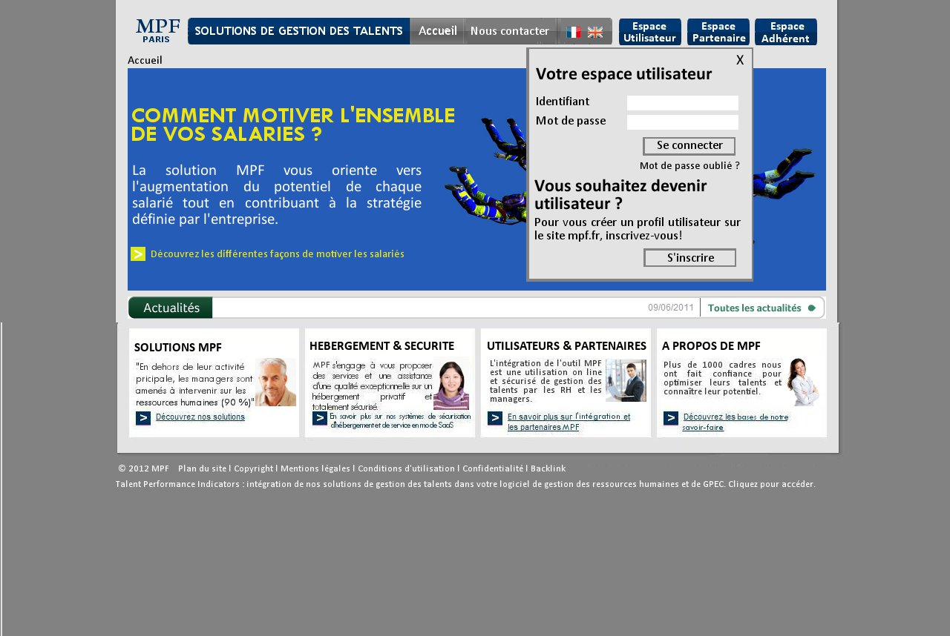

7

1

6

5

4

3

2

1

8

|  |  |  |  |  |  |
| --- | --- | --- | --- | --- | --- |
| Number | Title | Type | Displays Rules | Interactions rules | Comment |
| 1 | Titles | Text zones | Permanent |  | * Editable content in the BO * The designer can suggest prettier buttons * Texts are default justified. |
| 2 | Name of field |
| 3 | Empty field | Free field | Empty default | Write the login and password |
| 4 | “Se connecter” | Button | Permanent | By clicking, lead to the private user space |
| 5 | “Mot de passe oublié ?” (Forget password?) | Text zone | By clicking, re-send the password to the email address (used as login) |
| 6 | Text | Text zone |  |
| 7 | “S’inscrire” (register) | Button | By clicking, lead to the « Contact » page. |
| 8 | X | Button | By clicking, close the pop-up. |

* + 1. “Espace utilisateur” – before access to the questionnaire

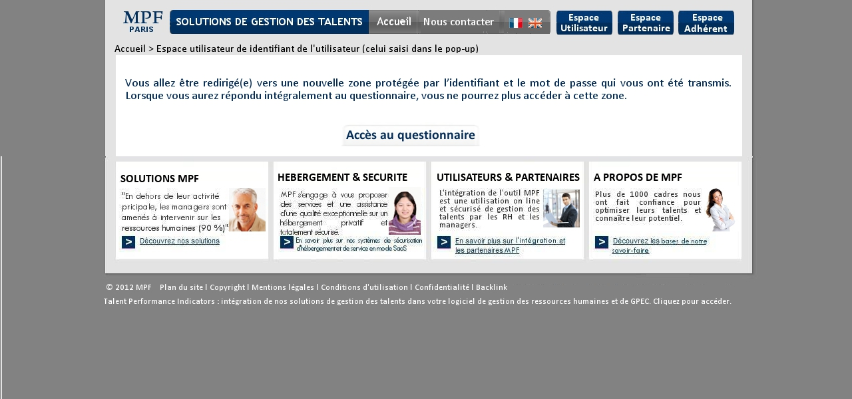

4

3

5

2

1

|  |  |  |  |  |  |
| --- | --- | --- | --- | --- | --- |
| Number | Title | Type | Displays Rules | Interactions rules | Comment |
| 1 | Header |  |  |  | See the « header » section |
| 2 | Breadcrumb | Text | Permanent | By clicking on « accueil », lead to the home page. | The last level of the Breadcrumb isn’t clickable. |
| 3 | Text | Text zone |  | * Editable content in the BO, * Plan the possibility of choosing the color, the font and the size of the text (possibility of bold). * Plan the possibility to change the URL. |
| 4 | Access to the questionnaire | Button | By clicking, lead to the URL: <http://www.mpf.fr/html/Qdebut-fr.html> |
| 5 | Footer |  |  |  | See the « footer » section |

* + 1. “Espace utilisateur” – Access to results

1

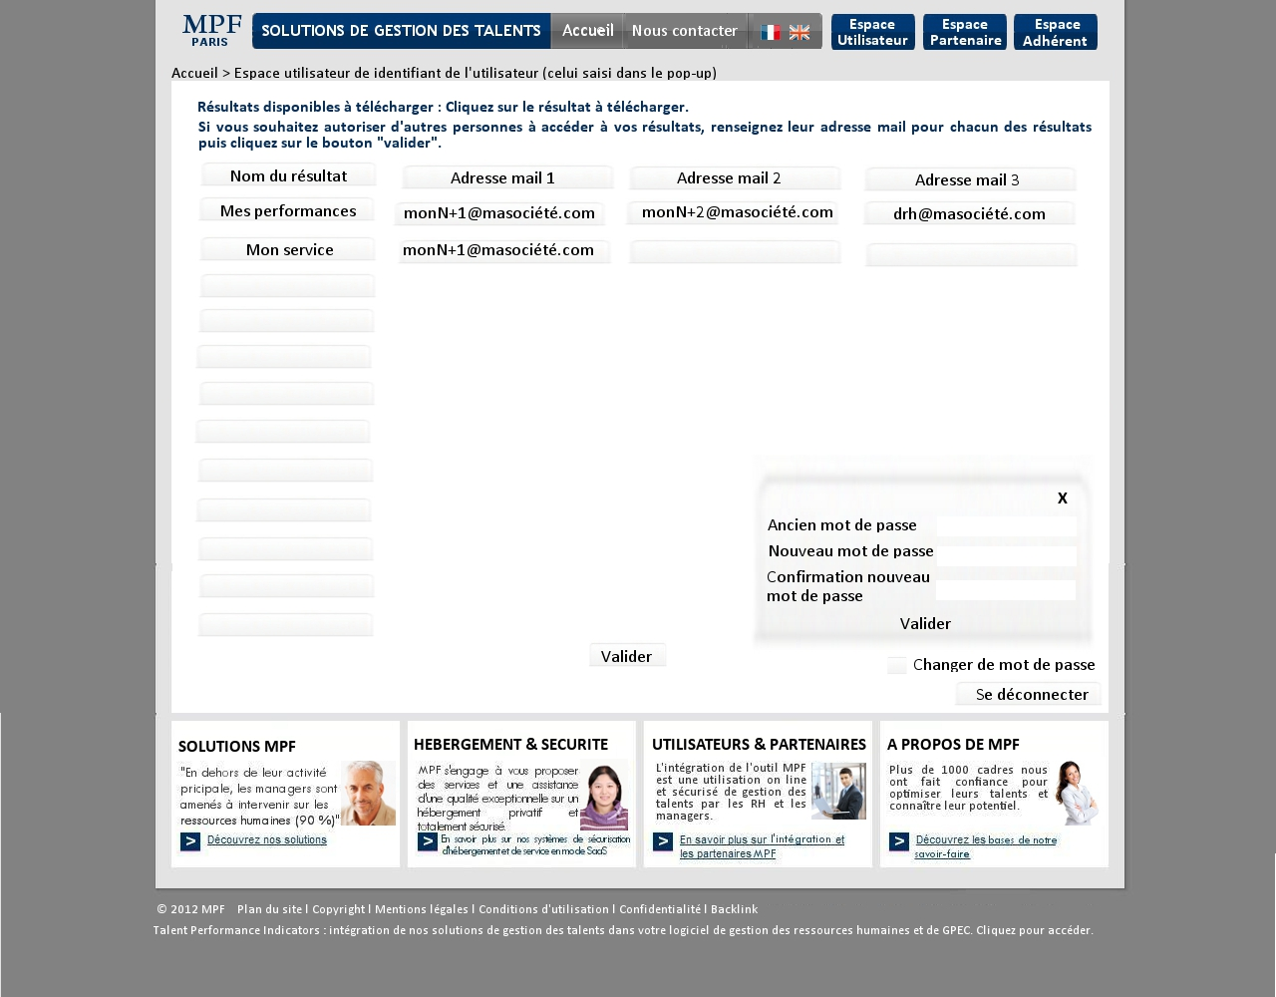

4

5

6

10

9

8

7

11

3

2

|  |  |  |  |  |  |
| --- | --- | --- | --- | --- | --- |
| Number | Title | Type | Displays Rules | Interactions rules | Comment |
| 1 | Header |  |  |  | See the « Header » section |
| 2 | Breadcrumb | Text | Permanent | By clicking on « accueil », lead to the home page. | |
| 3 | Text | Text zones |  | Editable content in the BO |
| 4 | Names of fields | Permanent |  |
| 5 | Name of the result | Plan 12 rows of possible downloadable results. 1st column for the result name, 2nd, 3rd and 4th columns for email addresses. When the mouse is over each results names automatically underlined it. | The result name is clickable only if there is something. The click launches the download. |
| 6 | Email address zones | Free fields | For each result, 3 “adresse mail” fields (maximum) can be filled. The access is possible only if there is a result existing. | Show the authorized email address. |  |
| 7 | “Valider” | Button | Permanent | 1er possibility: if none of the 3 “adresse mail” field are filled, le “valider” button is in grey (not possible to click on).  2ème possibility: if the “adresse mail” filed(s) is/are filled, when clicking, verify if the email addresses match with registered users, members or partners. If yes, the “valider” button is clickable, when the button is clicked display the following message: « Vos indications sont bien prises en compte. ». If not, until on of the email addresses is incorrect highlight this/those email address(es) (ex: red outline) and display the following error message : « Cette adresse mail est inconnue, merci de la corriger ou la supprimer ». When the correction is done, display the button « Sauvegarder les modifications » instead of the button « valider », When clicking, restart the match control of the email address (as described before) |  |
| 8 | Change password | Text zone with a check box | When the box is checked, the pop-up (10) is displayed. |  |
| 9 | Login | Button | When clicked:  1st possibility: if no action on the « adresses mails » fields, close the page and go to the home page.  2nd possibility: if email address changes had been saved, close the page and go to the home page (like the 1st possibility).  3rd possibility: If some change are not saved, display the following message in a pop-up « voulez-vous vous déconnecter sans sauvegarder les changements sur les adresses mails ? », with to buttons « Oui » and « Non ». When clicking on the « Oui » button, same as clicking on the “valider” button (cf :7). When clicking on « Non », close the page without saving and go back to the home page. |  |
| 10 | Pop-up |  | Display it only if the user has checked the « changer de mot de passe » box. | The user must fill the 3 boxes (ad a control of password function and a control of the 2 last fields match function). When clicking on the « valider » button, if the password to change exist and if the 2 last field match, the following confirmation message is displayed: “Votre nouveau mot de passe est bien enregistré”, a confirmation email (with the login and the new password) will be sent to the login email address. Otherwise, the following error message must be displayed: “le mot de passe est incorrect, merci de saisir à nouveau”.  When clicking on the « X » button, close the pop-up. |  |
| 11 | Footer |  |  |  | See the « footer » section |

* + 1. Pop-up displayed after clicking on “espace partenaire”

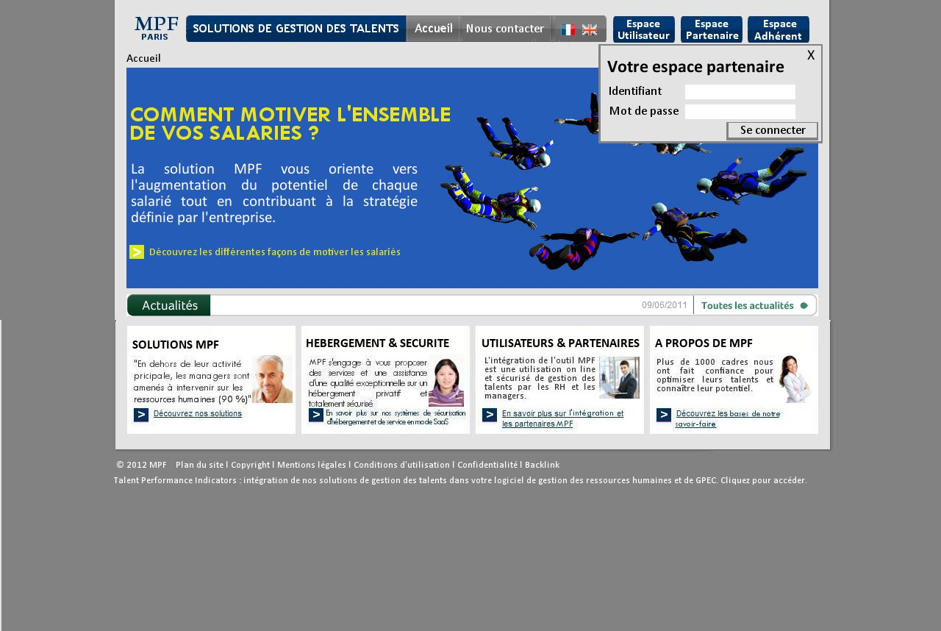

1

3

4

2

5

|  |  |  |  |  |  |
| --- | --- | --- | --- | --- | --- |
| Number | Title | Type | Displays Rules | Interactions rules | Comment |
| 1 | Title | Text zones | Permanente |  | Editable content in the BO.  The designer wan suggest prettier button. |
| 2 | Name of the fields |
| 3 | Empty field | Free field | Default empty | Fill the login and the password |
| 4 | “Se connecter” | Button | Permanente | 2type of connection are possible:  Type A (for ex. PARTNER205) : same as (4) of the 2.10.2 “Espace utilisateur – before access to the questionnaire”  Type B (for ex. [dupont@partner.com](mailto:dupont@partner.com)) : Access to a restricted area of results consultation :   * If an email address is associate to the results, in the email address alphabetic order, group the prefix (before @) in order to search with the company name (suffix). * If no email address are associate to the results, in the logins alphabetic order. |
| 5 | X | Button | By clicking : close the pop-up |

* + 1. Pop-up displayed after clicking on “espace adherent”.

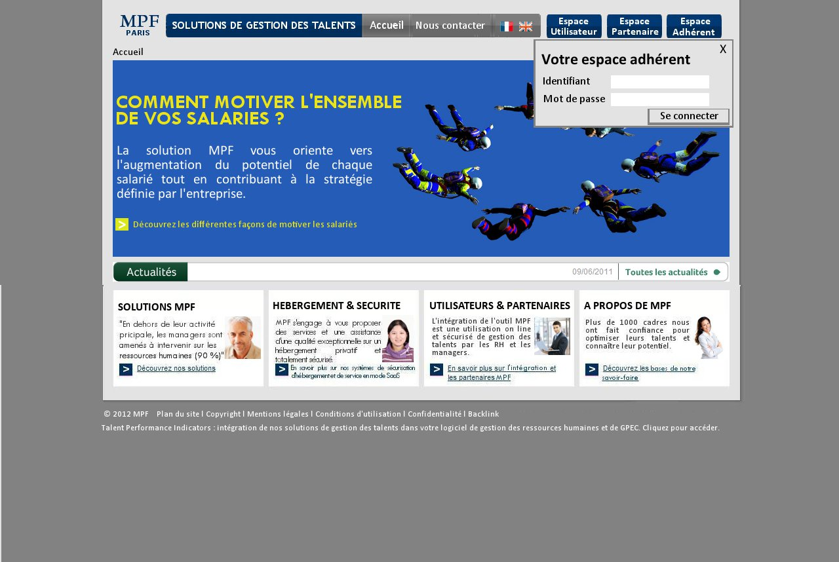

* + 1. Remark: same as the “Pop-up displayed after clicking on “espace partenaire””

# General remarks

* SEO: plan the possibility to modify URLs, the Meta tags (title, descriptions, keywords) and the Breadcrumb.